OCR GCE A Level
COMPUTER SCIENCE PROJECT
H446-03

Name: <David Rimmer>
Candidate Number: <2897>
Institution Name: <Salford City College>
Title of Project: Forest Tower Defence

H446-03 – Project CONTENTS
Table of Contents
A. Analysis 3
Problem Description 3
Stakeholders 4
Justification 4
A Computational Approach 4
Thinking Abstractly 5
Thinking Procedurally and Decomposition 5
Research and interview 6
Evaluation of research 8
Interview 9
Features 10
Essential Features: 10
Desirable features 12
Hardware and software requirements 13
Success criteria 13
Limitations 15
B. Design 15
Structure diagram 16
Sumary of Processes 16
Key variables and data structure 18
Class diagrams 20
Development Testing Plan 21
Algorithms 23
C.-Evaluation 27
Post development testing 27
Main menu – 21/06/23 27
Loading mob image – 07/09/23 28
Mob pathing problem – 07/09/23. 29
Spots for Towers – 19/10/23 32
Shop popup – 31/10/23. 34
Shop bar Jittering – 7/11/23. 36
Selecting a placement block – 12/03/24 38
Tower placement – 01/4/24 40
Tower selection – 05/04/24 41
Showing and hiding the upgrade shop – 09/04/24 44
Upgrade shop appearing when clicked on and the shop is open – 9/04/24 45
Bullets stop appearing After a period of time – 11/04/24 46
Creating waves of enemies – 13/04/24 47
Time delay for preperation at start of game – 13/04/24 50
Fixing altered code with enemy waves – 13/04/24 52
Usability testing 56
Success criteria 58
future development and Maintanace 60
Project Appendixes 62

Analysis

Problem Description
My game is a tower-based defence game which is based on surviving a set number of waves and keeping your lives to survive and protect your village. The game will allow for story progression through different levels protecting different villages as the player aims to fight off all the enemies and bring peace to the land. In the case the player loses, the game will restart. The game will consist of multiple levels, each with a background map with scenery and a path travelling from one side of the map to the other through which the enemies attacking you walk on. There will be a range of enemies including Goblins, Ogres and Wolves. The player will play the game by starting with a set number of points which can be used to build and upgrade towers placed in pre-set areas which will attack the enemies trying to attack your village. The game will have a main menu for levels selection and multiple onscreen UIs to display health, waves, tower selection and upgrading.
The problems I will most likely encounter will be with getting the UIs to properly open and close when prompted and work when buttons are clicked, as well as the bullet pathing for the attacks from the towers and getting them to properly hit the enemies.

Stakeholders

Stakeholder 1:

My first stakeholder is my friend Johnny Barnes. Johnny is a college student who has experience playing lots of games online with a wide range of experience and skills in multiple different genres of games. He has a qualification in GCSE Computer Science and is studying A level Computer Science, with some experience of coding complex algorithms and programs.

Stakeholder 2:
My second stakeholder will be my friend Elliot. He is an incredibly smart student studying A Level Computer Science who has lots of experience programming complex games including idle games and boss battle games in Python as well as experience in multiple languages. He also has lots of experience in strategy games like tower defence and idle games but can give a wide range of feedback on how to improve my game overall.

Justification

A Computational Approach
A computational approach is used as I am creating a computer game with game mechanics and graphics which are not achievable in the real world and must be created using a computer. This could not be made without a computer format due to its unrealistic theme of fantasy characters and fighting between enemies and the player through firing towers, which require algorithmic thinking implemented as a key feature in the game.

Thinking Abstractly
My program will be a game designed to entertain and challenge the player whilst also being simple and easy to understand for all levels of players. During the development of my program many aspects can be abstracted to save time in development and decrease the complexity of the code and reduce possible bugs further down the line of development when more and more complex features are overlapped. For example, in the context of my game, the bullets fired from towers on the map in theory never miss, therefore code to detect a collision between the bullets and enemies is not needed and can be removed, being replaced with code to take health from the tower’s target.

Thinking Procedurally and Decomposition
Whilst developing my game, I will need to break down my project into smaller parts and functions, which can all be dealt with separately which overlap and make the development process for my game more efficient and easier to complete.
A summary of decomposing my project into steps:
- Main menu
  - Play button which starts the game.
  - Quit button that closes the game window and suspends the code.
- Gameplay
  - Accessed through the Play button in the main menu.
  - Shop with selectable towers.
  - Placement spots where towers can be placed.
  - Enemies which automatically spawn and traverse the map.
  - Can select towers by clicking them.
  - Can upgrade towers whilst they are selected.
  - The game is won when all waves are completed.
  - Towers fire bullets at enemies.

Research and interview
To understand how I need to make my tower defence games, I played and experienced first-hand what tower defence games are.

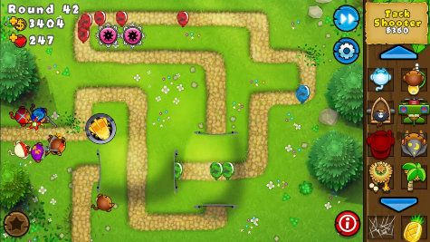
My first game being researched is Bloons Tower Defence 5:
Bloons Tower Defence 5 is a tower defence game that does not include a story. It instead allows player progression through beating maps in different difficulties awarding them with medals that add towards totals unlocking new maps. The game offered a large range of maps with 67 maps available to players. All maps offer 4 different difficulties: Easy, Medium, Hard, Impoppable. Easy difficulty has the lowest requirement for survived rounds and enemy difficulty, giving the user the most lives available, then in turn providing the least number of rewards to the user including a medal which does not count towards unlocking more maps as it is aimed to be used as a practice game mode for the user to learn to play the game. Impoppable has the highest requirement for survived rounds and lowest number of lives, highest enemy difficulty and the highest rewards, aiming to push the best players on the game.

In game, the user is provided with an on-screen UI which indicates the round, lives, points/money, settings, an option to speed up the game and a side section to see towers which can be bought. Towers bought can placed with a ‘drag and drop’ feature and placed anywhere within the placeable region which then attack the enemies within their tower range. Once a tower has been placed or clicked on/selected, another UI will appear on the bottom of the screen which shows information about that tower including the amounts of enemies defeated, upgrades, sell price and a targeting option. All towers that have been placed can be sold for a fraction of their original price. Upgrades for towers are given as two different ‘paths’ which that tower can be upgraded down, where only one can be fully upgraded to and the other only to half, allowing for two different types of that tower with different abilities and effects. Targeting features allow the player to change how that tower attacks, allowing for it to attack: the first enemy, the last enemy, the closest enemy, the strongest enemy.

The maps available to the player incorporate 3 different types of towers: air, land and water towers. Air and land towers are placed on land where air towers are then given the freedom to move within their range and water towers can only be placed in areas on the map with water. Most maps only allow air and land towers to be placed from not including water on the map where water towers can be placed but some allow for all 3 types to be used.

One problem with the game is that selecting towers can be hard and sometimes won’t work which should be avoided in the development of my game.

Overall, the game perfectly embodies tower defence games providing the user with a wide range of maps and tower possibilities to play with or challenge the user.

My second game researched is Plants vs Zombies:
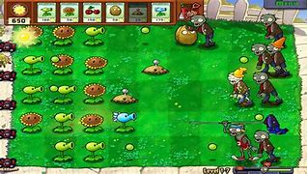

Plants vs Zombies is another tower defence game like Bloons Tower Defence but offers much smaller maps, less dynamic enemy movement and less towers available for use by the player. The maps remain the same in functionality throughout the storyline of the game with different scenery and progression in enemy difficulty. The main menu of the game has options to play the adventure game mode, the extra game modes or access help and settings options.
The adventure mode of the game consists of 6 stages that the player must work through completing each level before passing onto the next stage, with each stage containing 10 or more levels. Progressing through the adventure mode allows the player to unlock more towers which can be placed within the grid layout to defend your garden against the approaching zombies. The towers cannot be upgraded but stronger towers are unlocked for use as the story is progressed. The game provides no option to change the difficulty but the variety of zombie type changes as the story is progressed.
A problem with this game is with the placement of the towers within the available grid spots, as it is easy to accidentally place a tower in a neighbouring spot due to small placement boxes.

Evaluation of research
My research on the games Bloons Tower Defence 5 and Plants VS Zombies was extremely useful in exploring the style of tower defence games and the individual features in the two games. With Bloons Tower defence I am going to use a similar gameplay style with the use of dynamic movement with enemies traversing the path. My enemies will follow a path of less turns and more slow straight movement instead of fast speeds with lots of twists and turns. I will also use a similar idea of the UI for the placement of the towers available to the user and the UI for upgrading. The towers placed by the user, which are located on the sides of the screen are permanently there. If I can implement it, I will make them popup UIs which can be closed to expand the screen viewability. I don’t plan on using the placement system used in this game where towers can be placed anywhere in the available space. I will use the currency and counters, gaining money when enemies are killed, and having health, money, time and round counters on screen for the user to see. This game allows for all towers in the game to be available to the player all the time with a set cost to buy which I will implement into my game. I like the idea of the player having the variety of all the towers instead of a select amount. Bloons Tower Defence 5 is built off the idea of the player selecting different maps to play and beat but does not include a levelling system which gives the player full access to all maps from the start and does not restrict their choice. I will use this feature in my own game and give the player a selection of maps that are not restricted from use.

From Plants VS Zombies I will not be using the straight map system which only allows for enemies to move in straight lines down one of 5 different paths. Similarly I will use the placement system for placing towers onto the map, where set areas on the map, visibly distinguishable from the scenery, can be used to place towers. I will not be using the currency system from this game as it is based of gaining currency as time goes on and is not based off how many and which enemies are killed. Unlike BTD 5, Plants VS Zombies makes players go into the game with a small selection of towers which can be used. I will not use this as it gives the user a restricted usage for towers. They can use the full range of towers that are available to be used in the game. Plants VS Zombies uses the same straight pathed map style in every level with the only difference between levels being a change in scenery and difference in enemies attacking. I do not want to use a similar map style to this as it implements the same idea into all maps and provides no variety in map availability as it requires a levelling system to work which I also do not want to implement in my game.

Interview

Question: | Johnny | Elliot | Conclusion:
How do you expect the graphics and animations to be? | “The game will be simple so graphics and animations should also be simple to mirror that, and not overcomplicate the game.” | “The graphics and animations should be simple for a game like this but should also have some variety between the towers and enemy designs.” | The animations and graphics should be simple and not complex but also have variety.
How do you expect the enemies to function? | “Enemies should have fixed movement, with a health value which decreases when hit by a bullet and remove health from the player when they reach the end.” | “The enemies should have a fixed path to follow, with health that increases based on the wave the player is currently on. When they die, they should be removed from the screen.” | Enemies should have a fixed path to follow, scalable heath depending on the wave, take health from the player after reaching the end of the path and be removed from the screen when they die.
How do you expect the towers to function? | “I think the towers should shoot bullets with a cooldown in between, which then track a targeted enemy and disappear after hitting it.” | “There should be a few types of towers to give the player some variety, all with different features or attributes to the others.” | There should be multiple types of towers each with different attributes and designs. These towers shoot bullets which track the selected target and disappear upon collision. There will be a cooldown after a bullet has been fired.
Should towers be selectable? | “Yes, towers should be selectable so specific towers can be upgraded, you could possibly do this by clicking the tower you want to select.” | “Yes, adding this as a feature will make upgrading towers easier and allow for possible features, like showing the towers range whilst it is selected.” | Towers should have a selectable feature, to possibly use to upgrade the selected tower. It could also be used to show the towers detection range.
How should the shop work as part of the User Interface? | “I think the shop should have a button on the UI to open and close it, containing buttons to buy towers. Having a button to open and close it would be a nice extra feature to include.” | “The shop should remain open all the time to save time and reduce the amount of overlapping functions in the program.” | The shop should be open and closed through a button on the UI if possible.
How should the player be able to access upgrades for towers? | “The player should be able to access upgrades by clicking on a tower placed at a placement spot and selecting it, which will bring up a menu similar to the shop with buyable upgrades.” | “There should be a button in the shop which brings up a menu with buyable upgrades, which can be bought when a placed tower is selected. | I believe the best option to implement would be Johnnys suggestion, as it will be more convenient than selecting towers and opening the upgrade menu separately.
How should the wave feature of the game work? | “You should use a fixed number of waves the player can complete, before they win, has an infinite number of waves will be too complex to implement in a simple game.” | “Have a set number of waves the player must beat to win, having infinite waves will be difficult to code. Too many waves will make the game too long for its simple design.” | The game should have a set number of waves the player will need to complete to win. This will reduce the complexity of the code needed for this feature to be implemented.

Features

Essential Features:
Main Menu:
A main menu is important as it allows the user to navigate the options available before any game is started, including a scoreboard and the play option. Once play is selected, a selection of levels available to the user will appear, allowing the user variety in the maps. They can then select the difficulty level that they wish to play at. Selecting Scoreboard will bring up the scoreboard showing the longest time and highest round they have achieved on each map.

On-Screen UI:
An onscreen UI will allow the user to access the main features of the game, such as the shop, main menu and upgrade shop. The UI will consist of a simple bar and buttons which are pressable and will bring up the shop and take the user to the main menu when clicked.

Counters:
A health counter on screen for the user to see will show the user their set number of lives they have. As the game is based on surviving a life counter is essential to the user to show how close they are to failing and losing the game. The life on the counter is preset depending on the difficulty and will decrease for every enemy that reaches the end point of the map.
A money count on screen will display how much money the user has. This in game currency is used to purchase towers and buy their upgrades whilst in a game. Money is given to the user for every enemy that is defeated by the users placed towers and will scale with difficulty and the enemy type.
Towers:
Towers will be the main aspect that allows the game to function as the feature that allows the user to fight off the enemies attacking them and survive. The towers will each have options for upgrades which improve the damage and speed of attacks which help the user survive longer. This is essential as it is the only way for the user to fight off enemies and progress through the game.
Buildable areas placed on the background level are selectable allowing the user to choose and place a tower in the pre-set building areas. These are essential to allow the placement of towers so the user can properly play the game.

Enemies:
Each enemy will be uncontrollable by the user and follow a fixed predetermined path through the map. The speed at which each enemy moves at is determined by the type of enemy, the health of each type of enemy is mostly different and is correlated to how much health is removed from the user when that type of enemy passes the end point.

Graphics:
As the game is based on dynamic movement of enemies and tower attacks, the player needs to see clearly the background map of the game and the movement of the tower attacks and enemies including their speed and direction. These are essential to the user to allow them to see what is happening in game and play the game properly responding to the movement of enemies on screen.

Desirable features
Popup UI:
Popup UIs will be a desirable feature as it allows for less cluttered UIs to be fixed to the sides of the screen which reduce the size of the area used to play the game, providing a nicer and more tidy play screen. The popup UIs will be small and closable and fixed relative to the towers and useable areas selected.

Extra Counters:
A round counter will be used to show the rounds survived and the amount required to ‘complete’ the map selected. Once the map has been completed the counter will continue as a single counter only showing rounds survived until the user loses.
A time counter will show the user how long they have survived in the game for. This is essential for the user as it provides them with stats about how long they have survived in game and can be used to compare themselves to other players or keep track of their progress.

Scoreboard:
A scoreboard will be an extra option available in the main menu, like play and quit, that when clicked it will take the user to a scoreboard which shows them, all their previous attempts at the game. This could possibly include text showing the time they managed to survive for and the health they had left upon winning.

Hardware and software requirements

Hardware Requirements | Software requirements
Monitor – To display the game as it is run so the user can see what is happening and play the game.  Keyboard – For controlling parts of the game using keys  Mouse – For selecting onscreen aspects of the game like settings, towers and UI buttons  Operating system – Windows 7 or 10  Processor – 64-bit Processor  Memory – 4GB RAM  Disk Space – 5GB free disk space | Python – The game code will be written in python as it is a language I understand and can code in, so the player will need to have python installed to run the code and play the game.  Pygame – The player will need pygame installed on their device as it is a python library which helps in the development of games so that time can be saved during the development stage.

Success criteria

Feature | Justification | Success Criteria
Using the Main menu | The player must be able to navigate and use the main menu to access the features of the game. | Must have 2 buttons, Play and quit, which both work and take the user to the desired place or complete the desired action. There will be a background image on the menu and text showing the name of the game.
Using the On-screen UI | Allows the user to access and use the towers available, which is important as a main feature in the game. | The onscreen UI will be on the edge of the screen and fully interactable to select options involving towers to be placed on the map. The UI will possibly popup when selected on the map and be closable.
Counters | Allows the user to see stats on their survival as well as currency. | All counters will be displayed onscreen with a related icon next to the counter, only the round counter will be saved to the disk to be displayed on the scoreboard feature in the main menu.
Placing towers | This is the main feature of the game that the user uses to play the game using preplaced spots in the map. | Towers will have clickable icons on the UI which are selected when clicked changing the button colour and then can be placed by clicking a spot on the map
Tower Firing | Towers can fire and attack the enemies progressing on the map. | Bullets released from the towers will track towards the enemy and cause damage.
Enemy movement | Moves enemies along the path towards the end of the map to provide a threat to the user to make them lose. | The enemies will follow the set path on the map until it reaches the end.
Enemy death | Enemies are killed when enough damage is dealt to them from the attacks of towers. | Once an enemy dies the money counter will be increased by a set amount and the enemy will be removed from the screen.
Enemies reaching the end | Main objective of the enemy, successfully getting past the player and removing health from the player as a result. | When an enemy reaches the end health will be taken from the player, lowering the health counter and removing the enemy from the screen.
Updated Graphics | Graphics are updated constantly to show the movement onscreen and any changes in game. | Everything displayed onscreen will move independently of each other and will all move at the same time.
Upgradeable Towers | Allows the player to upgrade towers to keep up with the increasing health of the enemies. | Player will select a tower and upgrades will appear in the UI which can be clicked and take money from the player.
End Screen | Displays a win or lose message. | When enough enemies have reached the end of the path, and the players health drops to 0, a win or lose message must appear on the screen with a quit button below it.
Game Difficulty | Allow the player to select a game difficulty which will scale the health of the mobs and the amount of health they take from the player. This will add a small competitive nature to the game so the player can challenge themselves to beat the game on harder difficulties. | The game will have an option to select a game difficulty after the play button has been clicked.

Limitations

Number | Limitations and explanations
1 | The animations and designs of enemies, towers and backgrounds will be simple and abstracted down to be minimalistic.
2 | The game will have one main level (potentially two or more if possible) as having multiple will increase the complexity of the program which is not needed for a simple tower defence game.
3 | The game will not have many enemy types as like the game levels it will increase the complexity of my game and having too many different enemies will create confusion with players whilst playing the game.
4 | The games levels will not last long and will have a pre-set number of waves to be completed, as creating an algorithm that endlessly sends waves of enemies will be too time consuming and complex for me to implement, so a fixed number of waves will be used. It will also affect how the towers and enemies change as the waves progress, increasing complexity in those areas too.
5 | The game cannot have too many entities as python runs slower than other languages, meaning it can be easily overwhelmed by adding too many enemies, bullets and towers at once.

B. Design

Structure diagram
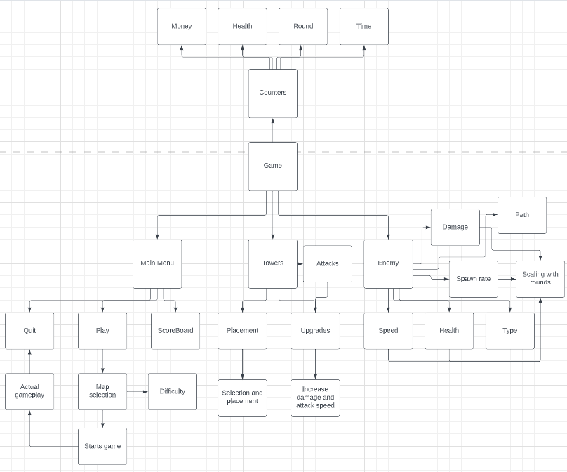
I created the structure diagram above to show all the features my game, it shows the main features of the game directly connected to the game block, with all the sub features of each category connected to their respective section. It’s also designed so that specific features can be removed from the final program and will not effect the functionality of the game; for example, the scoreboard feature can be removed from the main menu and it will not effect how the game will play, but removing a towers ability to shoot will cause the game to break down and become unplayable.

Sumary of Processes
Main Menu:
- Scoreboard button on the main menu which when clicked brings up the scoreboard screen.
- Play button on the main menu which when clicked, brings up the map selection screen.
  - Map selection screen contains multiple buttons which allow the user to select the map which they want to play on
  - Allows the player to select the game difficulty they wish to play at.
- The quit button on the main menu when selected will close the program fully, there will be a quit button in the actual game which can also be used to exit the current game in play returning the player to the main menu where they will have to select quit again to close the game.
Towers:
- Towers will be sprites which can be placed on the map in specific spots.
- Placement of towers will consist of clicking and selecting a tower on the UI and then clicking on the spots on the map to place the tower.
- All towers will have an automatic attacking system where all attacks happen at fixed rates and track the nearest enemy to deal them damage.
- Towers will have a specific UI for upgrading parts of the tower to increase attack damage and attack speed.
Enemy:
- Enemies consist of different types ranging in size and having different stats and attributes.
- All enemy types have a specific stat for health, speed, and damage:
  - Health represents how much life an enemy has and decreases when it is hit by an attack.
  - Speed represents the speed at which the enemy moves at.
  - Damage represents the amount of life taken from the user when an enemy reaches the end of the path.
  - All these stats will scale with rounds to make the game more difficult.
- Enemies will have a spawn rate at which they appear on the map, this will change with difficulty selected and the round at which the player is currently at.
- On the map all enemies follow the same preset path along the map to the end point that the user is protecting.
Counters:
- Counters will be on view on the screen whilst the game is being played and will be constantly updated the screen to show the proper value.
- The game will potentially have 4 counters which are:
  - Health counter to display how much health the player has left. This will decrease by the set damage of any enemy to reach the end point.
  - Round counter to display what round the player is currently on.
  - A Money counter to display how much money the player currently has. This will decrease when new towers are bought, or upgrades are bought for the towers.
  - Time counter to increase by 1 each second to track the amount of time that the player has survived for.
- Once the game has finished, the values for the health, round and time counters will all be saved and displayed on the scoreboard.

Key variables and data structure

Variable | Variable Type | Justification
Money | Integer | The money variable will keep count of how much money the player has, it cannot go below 0 and does not have an upper limit. It will increase when an enemy onscreen is killed and decrease when towers or upgrades are bought in-game.
Health – (Enemy/Player) | Integer | The health variable will keep count of how much health the player or enemy will have. For the player, it will decrease when an enemy reaches the end of the path. For an enemy, it decreases when bullets from the towers hit the enemies. It cannot go below 0 and will not increase.
Wave | Integer | The wave variable will keep count of the wave that the player is on. Will increase by 1 when the wave changes.
Time | Integer | The time variable will keep track of how long the player has survived for. It will increase by 1 for each second survived.
Damage – (Enemy/Player) | Integer | The Damage variable will be specific for each type of tower and enemy. For towers it will be the damage caused to enemies for each bullet that hits them, for enemies it will be the amount of health the player loses when an enemy reaches the end of the path.
Speed | Integer | The Speed variable is the amount that the enemies move on the screen per second.
Attack Speed | Integer | Attack speed is the rate at which the towers attack enemies, or the attacks per second.
Selected | Boolean | The Selected variable will allow the computer to know if something has been selected on the UI e.g. A tower or selected area on the map.
FPS | Integer | Determines the frame rate the code runs at.
Play | Boolean | Whilst true, the main game loop runs the event handler and all main functions of the game
Intro | Boolean | Whilst true the main menu function is run, and an event handler to run the button functions.
ActType | Integer | Holds a 1 or 2 for each type of tower, to be used to know what tower should be instantiated and placed at a placement spot.
Range | integer | Determines the range in which towers can detect enemies.
MobsInWave | List | An attribute of the player class. It will contain the number of enemies that need to be spawned each wave.

Class diagrams

Tower Class | Placement Block Class | Mob class | Player Class
Attributes:  self.image  self.rect  self.rect.x  self.rect.y  self.key_time  self.cooldown  self.range  self.type  self.visibility  self.Tselected  self.TselectedTime  self.name  self.RangeLevel  self.DamageLevel  self.DmgBase  self.damage | Attributes:  self.image  self,rect  self.rect.x  self.rect.y  self.clicked  self.key_time  self.type  self.action  self.lock  self.TowPlc | Attributes:  self.image  self.rect  self.rect.x  self.rect.y  self.xholder  self.path  self.pathT  self.vel | Attributes:  self.health  self.money  self.key_time  self.PlacementTime  self.MobsInWave  self.WavesBool  self.MobSpawned  self.WaveDelay  self.startDelay
Method:  getCooldown()  setCooldown()  ChangeCooldown()  drawR()  getSelected()  setSelectedT()  setSelectedF()  getX()  getY()  set()  GetTime()  ChangeTime()  setTime()  updateT()  pick_target()  bullet()  getRngLvl()  getDmgLvl()  UpgradeDamage()  UpgradeRange() | Methods:  getTowPlc()  setTowPlc()  getClicked()  getX()  getY()  getType()  pressed() | Methods:  drawP()  Move()  getX()  getY()  End() | Methods:  SetPT()  GetPT()  ChangePT()  Take_health()  Get_health()  getMoney()  GiveMoney()  TakeMoney()  GetTime()  ChangeTime()  setTime()  waves()  getMobSpawned(  setWaveDelay()  ChangeWaveDelay()  getStartDelay()  changeStartDelay()

Bullet Class | ShopBar Class | ScreenBar Class
Attributes:  self.image  Self.rect  self.x_move  self.y_move | Attributes:  self.image  Self.rect  self.Status  self.Ustatus  self.rect.x  self.rect.y  self.key_time  self.flag | Attributes:  self.image  Self.rect  Self.UP  self.rect.x  self.rect.y
Methods:  update()  deleteB() | Methods:  GetTime()  ChangeTime()  setTime()  GetStatus()  SetStatus()  hideShop()  ShowShop()  SetFlacg1()  SetFlag2()  GetFlag()  ShowUpgrade()  HideUpgrade() | No methods

Development Testing Plan
During the code development I plan to use a white box approach when testing bugs which appear with each function of the game. This will allow me to deep dive directly into where the problem has occurred. Having access to the console means I can print statements and check which functions are run and which are not. This is to successfully fix any bugs that occur.
For usability testing, I plan to take a black box testing approach to test the final product of the code and play the game without knowing what works behind the scenes in the code. I plan to test the code using test data which is within the range of expected use, test data at the border of expected use and extreme test data outside the range of expected use so the limits of the program can be fully tested and pushed to test if it will break down.
Test | What are you testing for? | Why is it being tested?
1) | Testing the main menu functions correctly, and all button on the main menu work and complete the desired function. The play button must be tested to start the game up and continue with the games processes, whilst the quit button must close the game and stop the code running. | It is the first thing which appears when the code is ran and allows the player to start the game and play it as well as quit the game properly when they are finished playing.
2) | That all mobs follow the set path correctly to the end of the map. | It is important they all follow the same path so the mobs go close to the towers and give the user a chance to defeat them. Once the mobs reach the end of the path health will be taken from the player so it is important this works correctly
3) | Testing towers can be properly placed on the map. | Towers are the main aspect of the game and allow the player to fight back against the enemies traversing the path. If the towers cannot be placed, the player cannot fight the mobs and the main function of the game breaks down.
4) | Towers can be selected and only 1 tower can be selected at 1 time. | Towers need to be selected to be upgraded and increase their damage and range in response to the scaling of the mobs with waves. If this feature breaks down the game is only playable in its first few stages of play and will become unplayable and unwinnable.
5) | Mobs take health from the player. | It is important that the mobs take health from the player as the game is win or lose, if health is never taken from the player it is a win every time and the game is not played fairly.
6) | Player is given money when a mob is killed | Mobs must give the player money when they are killed to allow the player to use the upgrading feature of the towers and place more towers to respond to increase in health and speed of the mobs as the game progresses, without this the playability of the game breaks down and the player can no longer win the game.
7) | Testing that all buttons on the UI inside the game are usable and work properly. | This allows the user to properly play the game, to access the shop and go back to the main menu to pause the game or to quit out of it. Without the shop the player cannot place towers and play the game and without main menu button the player can’t quit the game safely terminating the code, so it is vital these buttons work.

Algorithms

The menu for the game contains two buttons, play and quit. Clicking the quit button is a simple process of calling the pygame.quit() function and the quit() function which will stop the code running and close the window. Pressing the Play button will set the intro variable to false stopping the main menu function from running and sets the play variable to True which lets the game_loop() function run its while loop which is responsible for running all the processes and functions in the code and allowing the game to run. The main menu is run by calling the main_menu() function.
Algorithm for Menu Navigation

Algorithm for mob pathing

The algorithm for mob pathing exists as a callable method in the mob class called move(). This uses a list, of endx and y values provided a mob object is created, and a list of true and false values, showing whether a mob had reached a certain point on its path yet. The algorithm increases or decreases the x and y values until they match the end points and the corresponding positon in the second list is set to True to show that the mob has reached that point in its path and will move it to the next position.

The algorithm for tower placement starts with the pressed() method in the PlacementBlock class. This takes the position of the mouse and the click status of the mouse. This is then used to check whether the left mouse button has been clicked and if it has checked whether a tower type has been selected in the shop UI and that the mouse is within the dimensions of a placement block. This then sets the type of attribute of the placement block to the same as the type of tower placed at its position, and locks the placement block so another tower can’t also be placed there.
The next part of the algorithm takes place in the main game loop where a for loop iterates through each block within the block group, checks if the left mouse button and then calls the pressed function for each block, passing the current selected tower into the method. If a tower hasn’t already been placed at this block, a tower type is selected, and the block has been clicked then a tower object will be created and placed at the placement block.
Algorithm for tower placement

The algorithm for tower selection is split into two parts, selecting a tower whilst a tower isn’t already selected and selecting a tower whilst a tower is already selected. First a for loop iterates through each tower already in the tower group and checks whether it has been clicked, checking the left mouse button has been pressed and the mouse is within the dimensions of the tower. The tower is checked if its already selected or not, if it hasn’t been then a second for loop iterates through the tower group again and sets their selected attribute to False and then sets the clicked towers selected attribute to True, the ShowUpgrade() function is also called which brings up the upgrade shop UI and close the Shop if that is open at the time of selection. In the case the tower is clicked whilst already selected, it goes through the same process and the selected attribute is set to False.
Algorithm for tower selection

Algorithm for enemy waves
The waves algorithm is a method inside the player class, is uses a list of the number of mobs per wave, a list of Boolean values to say whether they have been spawned or not and a list to say what waves have been completed will be used, which are all attributes inside the player class. If the mobs have not already been spawned, a for loop will spawn them on the map with a position offset. Once they are all spawned, the mob group is checked until all the mobs have been deleted or killed by the player and if the mob group is empty the wave is changed to completed in the list of Boolean values and the next wave will begin. This is repeated for 10 waves.

C.-Evaluation

Post development testing

Main menu – 21/06/23
In my main menu, I intend to have a background image to set the theme of the game and buttons onscreen for map selection, scoreboard and quit. Each will take the player to a different menu screen when clicked.

Test 1:
Test number | Test | Expected outcome | Actual Outcome | Pass/Fail
1 | Testing displaying the main menu | The main menu will appear onscreen with an image for the background. | When the code is run the menu appears onscreen but the background image supposed to be displayed cannot be found within the file directory. | Fail
An error occurred when the code could not find the image that was saved in the same folder as the main code.
There was no error within the code when loading the image, but it couldn’t find the image in the folder.

Remedial action:
To fix the problem, I used the imported os library to create a variable that stores the path to a file stored within your computer. This is then put into another file to get the directory of the file.
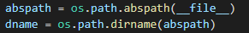
The variable is then included into the original code blitting the image on the screen.

Test Number | Test | Expected Outcome | Actual Outcome | Pass/Fail
2 | Testing loading up the main menu | Menu loads up with the background image displayed | The Main Menu loads up displaying the background image | Pass

Loading mob image – 07/09/23
When loading the image of my mob, a black square would be placed around the mob behind the loaded image on screen.

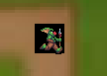

Remedial action

The black square appeared because the code loaded a surface as the class image and then an image ontop of the square.
Image of the mob set as a black surface.
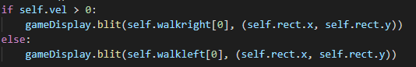 Whilst also loading the mobs image ontop

Instead, self.image must load the image instead of a surface.

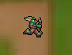

Test 2:

Test Number | Test | Expected Outcome | Actual Outcome | Pass/Fail
1 | Testing if the black square has been removed | No black square behind the mob | No black square behind the mob | Pass

Mob pathing problem – 07/09/23.
Whilst the mob is following its movement code along the map path it stops midway and doesn’t continue walking

Remedial action
The problem with the code causing this was a logic error with the code, a list of true and false statements is used to know whether the mob has reached a certain point.
The code was written so that the value would remain true as it tried to follow the path, but this restricted its movement as it was still trying to keep the mob at the values of the previous end points.

To fix this, I set the values in the list to false after the point has been reached so it doesn’t stop the mob from continuing its movement.
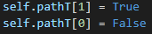
This is used throughout the same section of code for every section of movement, so none of the movement becomes restricted.
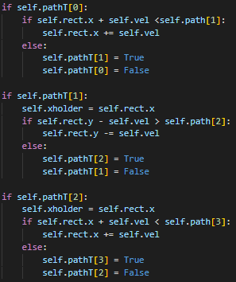
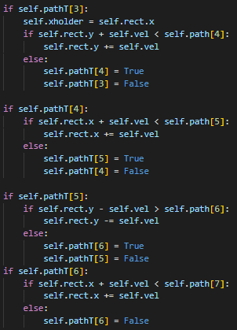

Test 3:
Test Number | Test | Expected Outcome | Actual Outcome | Pass/Fail
1 | Testing that the mob follows the preset path across the map | Mob sticks to the path on the map and moves from the spawn to the end on the other side. | Mob follows the path to the other side as intended. | Pass

Shows mob at the start of its path Shows mob following the path towards the end:

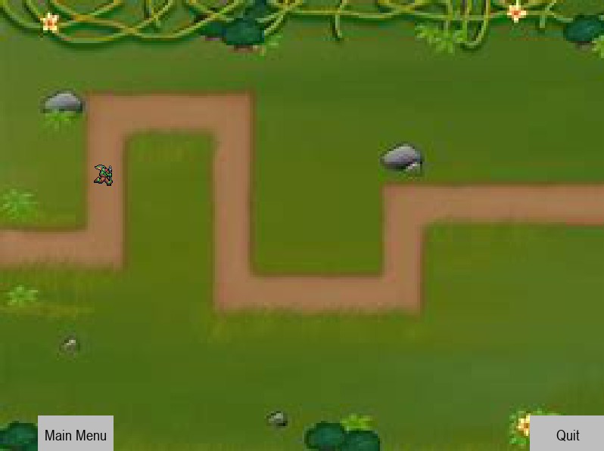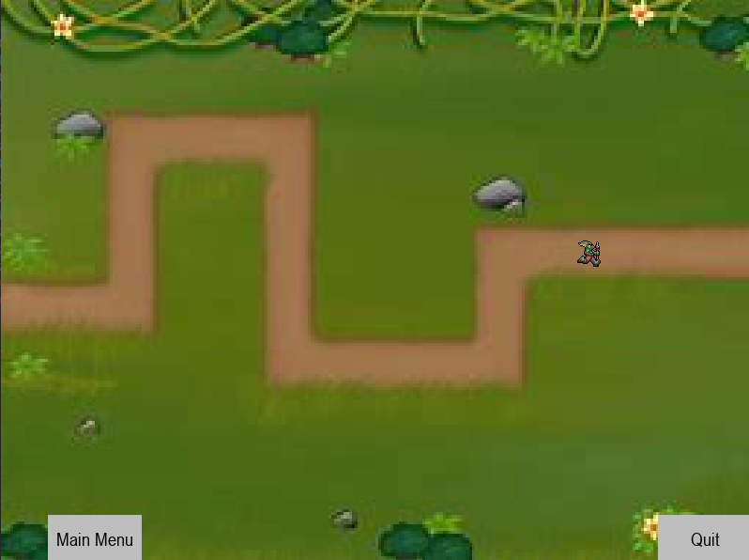

Spots for Towers – 19/10/23

Upon considering multiple methods of tower placement, me and my stakeholders decided the best and easiest method to use would be selecting a tower and clicking a placement spot on the level.

I started by creating a new class for placement blocks to be created and placed around the level, displaying them as a 60-pixel by 60-pixel square as a surface, and then converting it to a rect and changing its x and y values to control the location of where they will be. The x and y values are passed into the object when it is created.

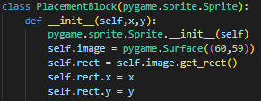

I then created two objects of the placement block class and tested that they appeared on the screen.

Test 4:

Test Number | Test | Expected Outcome | Actual Outcome | Pass/Fail
1 | Load up the program, click play and check that two black boxes have appeared on the screen | Two black boxes are on the map. | Two black boxes are placed on the map. | Pass

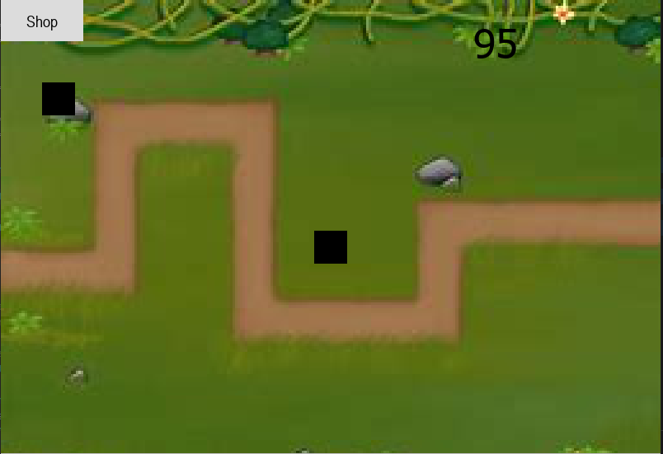

Shop popup – 31/10/23.
When the shop button on screen is clicked it should bring up a bar at the bottom of the screen which will have 3 options of towers to use. When the shop button is clicked the bar does not appear, but no errors are returned, so there is a logic error with the code.

Remedial action

The logic error was placed in the Shop function which shows and hides the shop whilst the game is running.

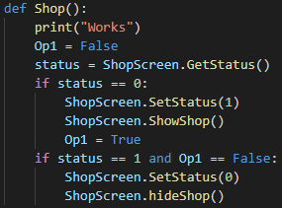

The function ShopScreen.SetStatus() set the status variable in the object ShopScreen and then called the show and hide functions in which it checked the value of the status variable, which was setting it to the opposite value it was checking for.

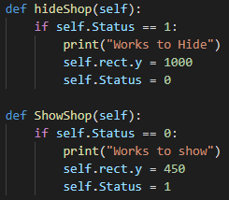

Removing the setting function fixed the logic error and allowed the shop bar to show and hide when the button is clicked.
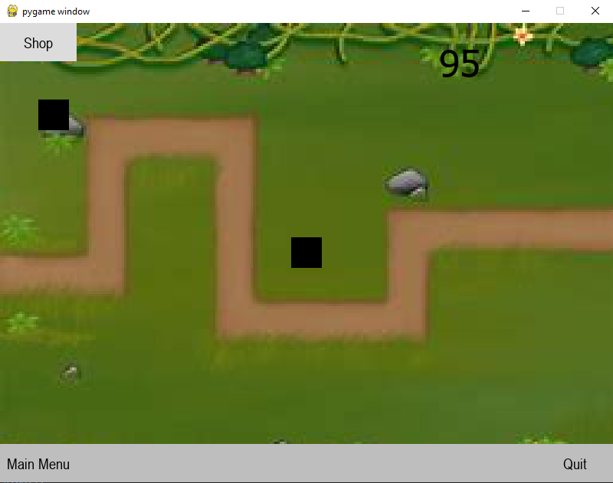

Test 5:

Test Number | Test | Expected Outcome | Actual Outcome | Pass/fail
1 | Testing the functionality of opening and closing the shop. | Shop button is clicked, and it opens the UI at the bottom of the screen | Shop button is clicked, and the UI opens at the bottom of the screen. | Pass

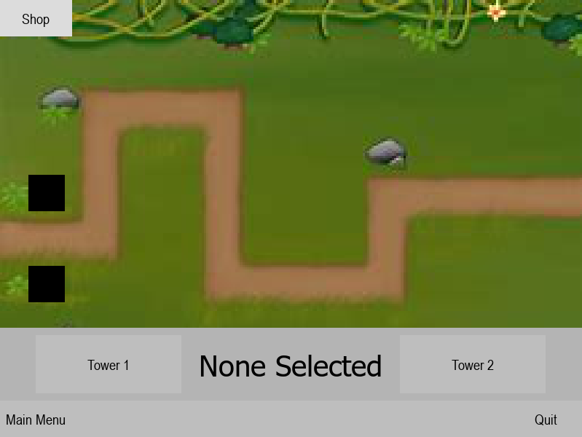

Shop bar Jittering – 7/11/23.
When the mouse is held hovering over the shop button, it jitters on screen being shown and hidden. It also creates problems when the mouse is only clicked once it has a chance to open then close the shop.
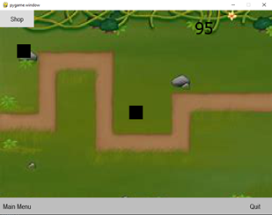
Remedial Action:
To fix the jittering problem, there needs to be a timed delay after the button is clicked until it can be clicked again. Using time will freeze the whole game during the pause, so instead a timer is used which matches the clock speed of the game.
Code in main game loop.
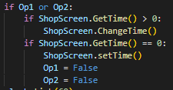
Code in shop function for showing and hiding the shop
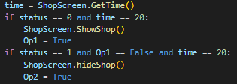

Test 6:
Test Number | Test | Expected Outcome | Actual Outcome | Pass/Fail
1 | Open and close the shop using the onscreen button | Shop opens and closes with a slight delay between | Shop opens with a slight delay when button is clicked. | Pass

Selecting a placement block – 12/03/24
Problem:
When a placement block on the map is clicked it appears selected despite no tower being selected in the shop.

Remedial action:
To fix this problem I created the function below as a method in the placement block class, called pressed which takes the type of tower selected in the shop as a parameter.
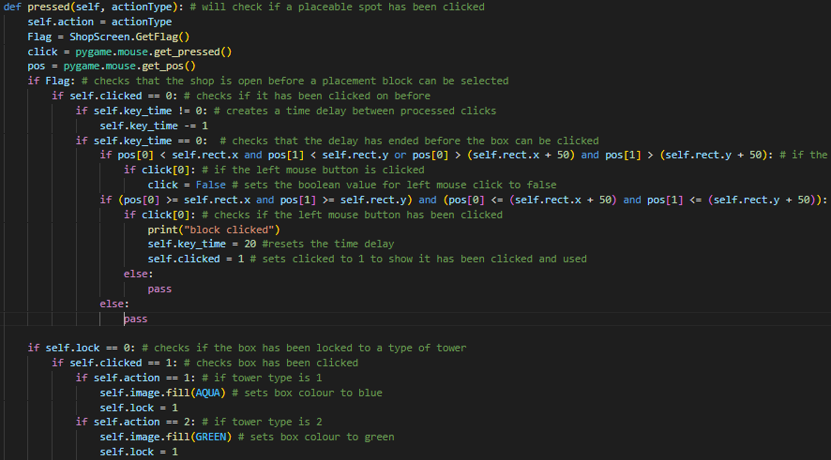

The ActType key variable is passed into the function when it is called in the main game loop and assigned to the blocks self.action attribute. The Boolean value of the shop status is found using the GetFlag() method of the shop object and stored in flag, the mouse coordinates are found, using pygame.mouse.get_pos(), and stored in the pos variable and the clicking status of the mouse is found, using pygame.mouse.get_pressed(), and stored in the click variable.

The algorithm starts by checking that the shop is open and that the placement block has not already been clicked, and then that the time delay between clicks has passed. The algorithm then uses the pos variable to check that the mouse is within the dimensions of the placement block when it was clicked, if the mouse was on a placement block the self.clicked attribute is set to 1. If the mouse was not over a placement block, then the code will call the built in function pass and nothing will happen. The self.lock variable is then checked to make sure a tower hasn’t already been placed here, if one hasn’t then it sets the type of tower placed at the placement block by changing the colour of the block and then sets the self, lock attribute to 1 so no other towers can be placed there.

Test 7:
Test Number | Test | Expected Outcome | Actual Outcome | Pass/Fail
1 | Click on a placement block and it doesn’t print the test statement “block clicked”. | Block is clicked and no message is printed. | The block is clicked and the test message is not printed. | Pass
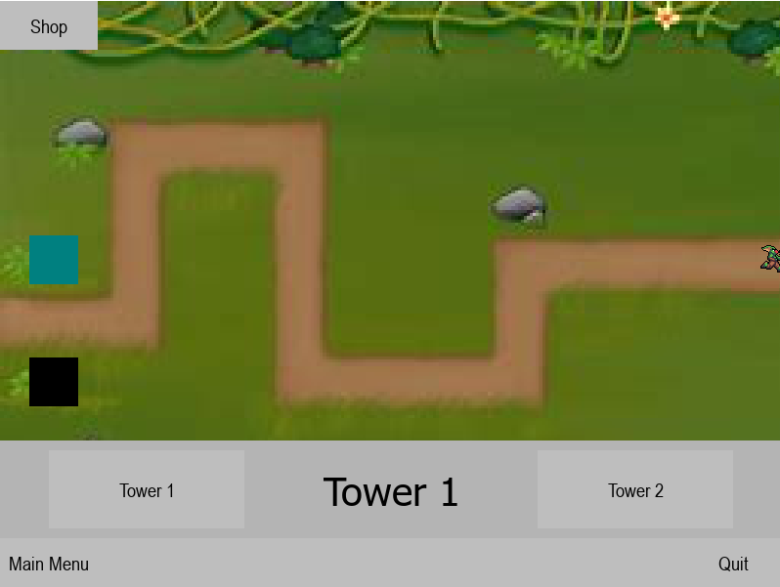
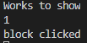
“Works to show” – test for shop.
“1” – tower 1 selected.
“block clicked” – test message showing the block was clicked.

Tower placement – 01/4/24
Problem – When a placement block is clicked whilst a tower type is selected in the shop, any towers already placed also changed type when a new type is selected.
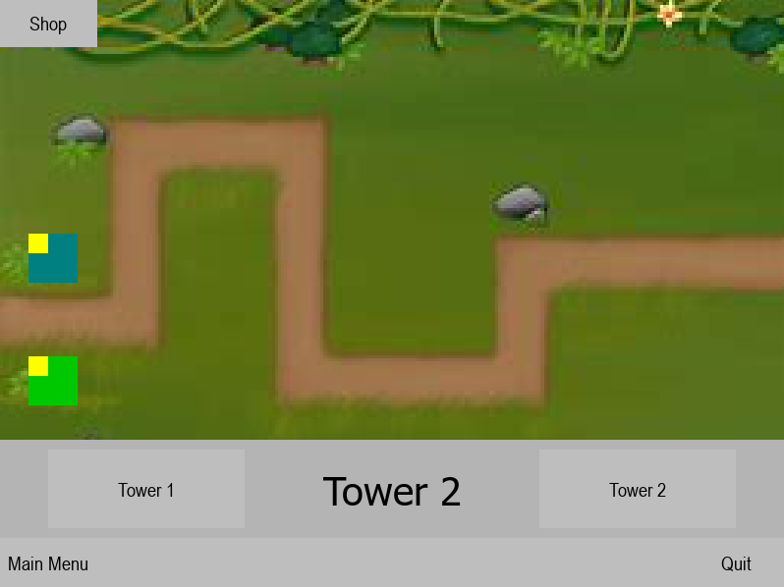

Remedial action – After looking through the functions in the Placement Block class, the function setting the Tower placed variable to True was misspelt, meaning that it was not changed so the loop never stops processing and didn’t lock the towers into their specific type. So properly spelling the variable fixed the problem.
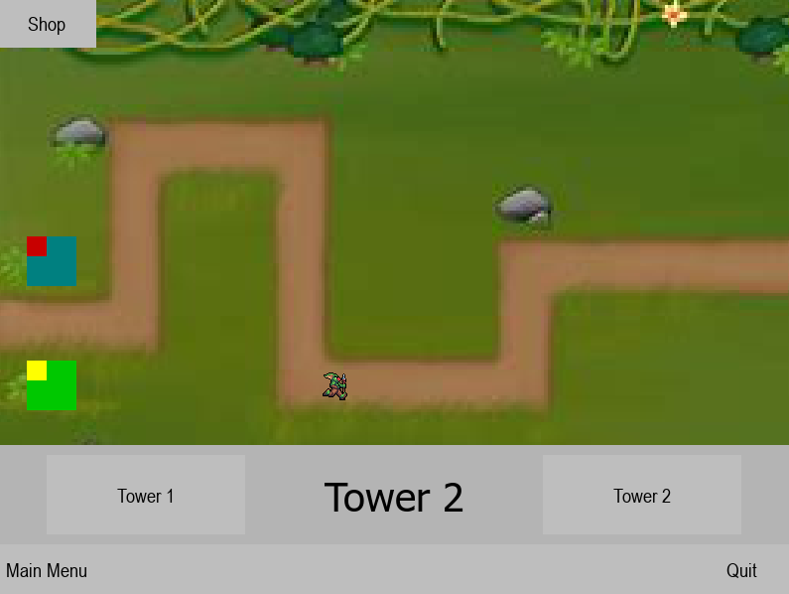
Test 8:

Tower selection – 05/04/24
Test Number | Test | Expected Outcome | Actual Outcome | Pass/Fail
1 | Place two towers and they both have different colours, showing they are different types. | One tower is red, the other tower is yellow. | One tower is red and the other is yellow. | Pass
Problem – When a tower onscreen is selected it should set the selected value of all the towers to False then change the tower that has been clicked to have a selected value of True. When the code is run, all the ranges of the towers would show, and the value of the tower would go from True to False or False to True no matter which order the code was placed in.
Remedial action – First, I changed the order of my loop so an if statement checks whether a tower has been clicked on before looping through every tower, then to fix the problem I put the if statement, checking if the tower has already been selected, first in the loop and introduced a break function at the end of the statement so it fully breaks out the validation loop and doesn’t change the value of the selected attribute. Despite fixing this, the ranges of the appeared disappear and reappear, but the towers appeared selected.
Test 9:
Test Number | Test | Expected Outcome | Actual Outcome | Pass/Fail
1 | Towers placed will be clicked on and True or False should be printed in the console to show whether a tower has been selected or not. | The tower is clicked on and the value of the selected attribute changes in turn and not False to True, and the tower ranges show and hide when clicked. | When the towers are clicked on the value of the selected attribute changed properly but the ranges do not show and hide but stay permanently there. | Fail
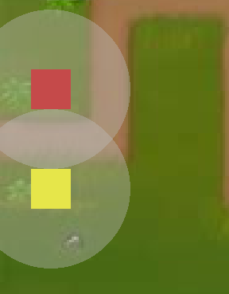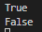
Picture of towers on map picture of console showing selection change
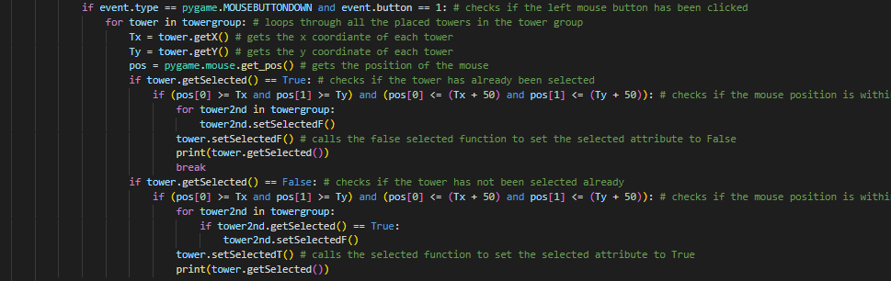
Second Remedial Action – The changing of the visibility of the towers’ range is controlled by the tower.getSelected() method of the tower class. In the class’s method, the value of the attribute is changed from 100-0 when a tower is unselected and this was being done by changing the value of the variable self.visibility.
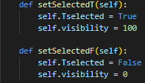
To fix this I changed the function so that it changed the visibility of the range directly instead of through a variable.
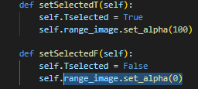
And set the original visibility of the range to 0, so we can see the range go away when it’s not selected.

Test Number | Test | Expected Outcome | Actual Outcome | Pass/Fail
2 | Towers are clicked and the range appears and disappears when the towers are selected and deselected | Range should appear and disappear when clicked | Range appears and disappears when clicked. | Pass
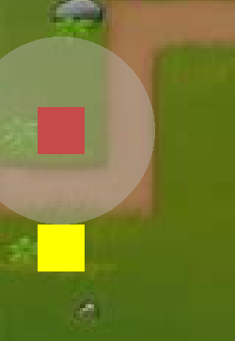

Showing and hiding the upgrade shop – 09/04/24
Problem – When a tower is placed at a spot it will appear selected but the upgrade shop will not appear, this works when a tower is placed for the first instance but when a second one is placed the shop is closed instead of remaining open.

Remedial action – I added a small time delay after placing a tower so the following functions to select and deselect the towers aren’t processed and changed a line of code in loop, which went through all the towers in the tower group and first checked if they had been selected and then set the selected attribute to false, so that it changed all the towers’ selected attribute to false.

Test 10:
Test Number | Test | Expected Outcome | Actual Outcome | Pass/Fail
1 | Testing that all towers are deselected when the shop is closed or another tower is selected, after being placed. | Shop is closed – both tower ranges are hidden.  Other tower selected – Only the clicked on tower is selected | Both Tests give results as expected | Pass
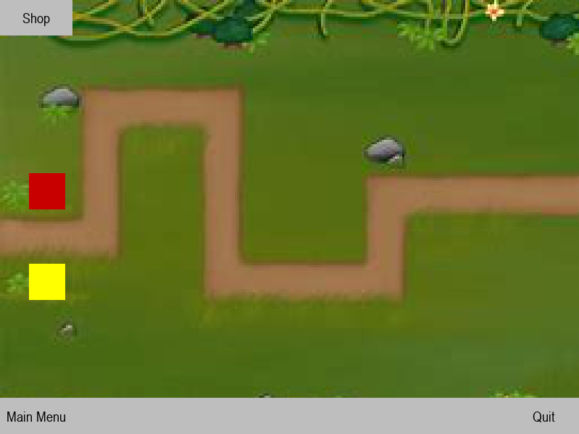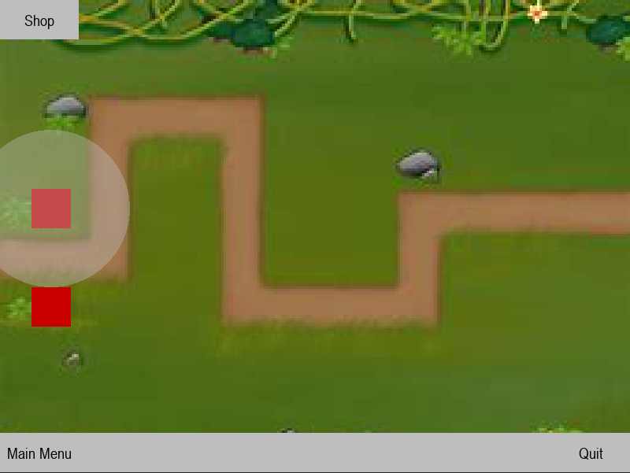

Upgrade shop appearing when clicked on and the shop is open – 9/04/24

Problem:
When the shop is open and a tower on the screen is clicked, the tower is selected but the upgrade shop does not appear in place of the shop, and the shop closes.

Remedial Action:
The reason the upgrade shop would not appear was due to code I missed out at the end of the UpgradeShop() function where the buttons which show when the shop is opened are not moved to a position outside the dimensions of the window, and as the shop and upgrade shop are the same colour I did not notice this.

Code added to fix this issue:
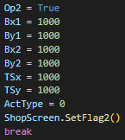
Test 11:
Test Number | Test | Expected Outcome | Actual Outcome | Pass/Fail
1 | A tower will be clicked whilst the shop is open. | The tower will show selected and the shop will be closed and the upgrade shop will be opened | The upgrade shop opens and the shop closes when a tower is selected, whilst the shop is open. | Pass

Bullets stop appearing After a period of time – 11/04/24

Problem:
Whilst a mob is within the range of a tower a bullet will be created and fired at it. Whilst the game is running for a period of 30 seconds or more, bullets no longer appear from the tower and instead blip across the screen to the mob and disappear.
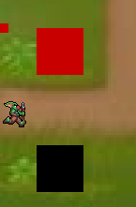

Remedial action:
The issue of the bullets not appearing is caused by lag, as lots of bullets are constantly created but never destroyed so they drift off infinitely and are constantly drawn and processed as part of the bullet group. To fix this issue I created a delete method within my bullet class which ‘killed’ the bullets when they went out the dimensions of the window, so they didn’t build up and cause the whole program to slow down.
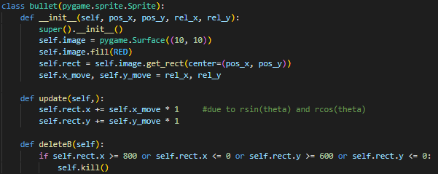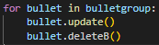
Test 12:
Test Number | Test | Expected Outcome | Actual Outcome | Pass/Fail
1 | Testing that the bullets appear consistently when the towers fire. | Bullets can be seen moving from the centre of the tower to the mob within range. | All bullets can be seen being created and moving towards the mobs. | Pass

Creating waves of enemies – 13/04/24
Problem:
Originally I had planned to take an approach of creating lots of mobs (Objects of the mob class) and offsetting where their x and y values so they appear on the screen with a gap between them, but due to the high number of enemies that appear in the later rounds it becomes highly time consuming and the code is very inefficient.

Remedial Action:
To fix the problem, I decided to take a similar approach to how I coded the pathing for the enemies, by creating 3 new variables in the player class.
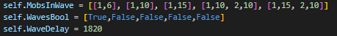
The self.MobInWave variable contains the type and amount of mobs that will be spawned for that wave, the self.WavesBool variable contains Boolean values in the same positions as the wave contents in self.MobInWave So the waves that have been completed can be tracked, and self.WaveDelay holds the value of ticks for a time delay factoring in the time it takes the last mob to complete the full path of the screen and a 15 second wait between waves.
I then created 3 methods for controlling the time delay, one to set self.WaveDelay to 0, one to return the value of self.WaveDelay and one to increase the value of self.WaveDelay by 1.
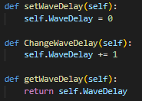
The setWaveDelay() function is used inside the waves function which controls which wave the player is on.
Small section of the waves function which shows the use of setWaveDelay() to set the delay to 0 after a wave has finished being created:
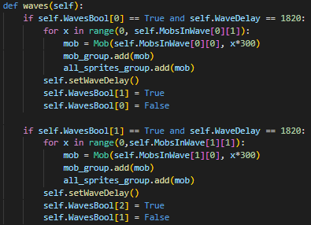

This small section of code in the main game loop controls increasing the time delay by 1 per tick to have a time delay between waves:
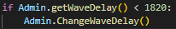
Test 13:
Test Number | Test | Expected Outcome | Actual Outcome | Pass/Fail
1 | Testing that waves of enemies. | Two waves of enemies should appear with a delay in-between. | Two waves of enemies appear with the expected amount of delay in-between. | Pass

Time delay for preperation at start of game – 13/04/24

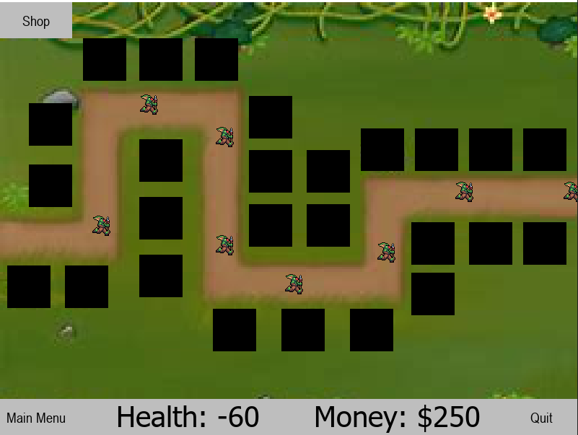

Problem:
Next I needed to implement a time delay at the beginning so the player can place down and upgrade towers to prepare for the game to start.

Remedial Action:
To do this I used the same process of creating a delay variable in the player class and 2 methods to get and change this value.
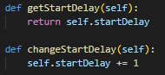
I then made a small if statement in the main game loop that increased the value of self.startDelay by 1 if it was less than 1200 to provide a 20 second delay before any waves start to occur.
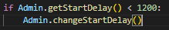

Test 14:
Test Number | Test | Expected Outcome | Actual Outcome | Pass/Fail
2 | Testing for a delay when the game is first started. | There is a 20 second delay before any mobs appear | There is a 20 second delay before mobs appear at the start of the path. | Pass
Showing that towers have been placed in the starting time delay to allow the player to prepare for the first wave:
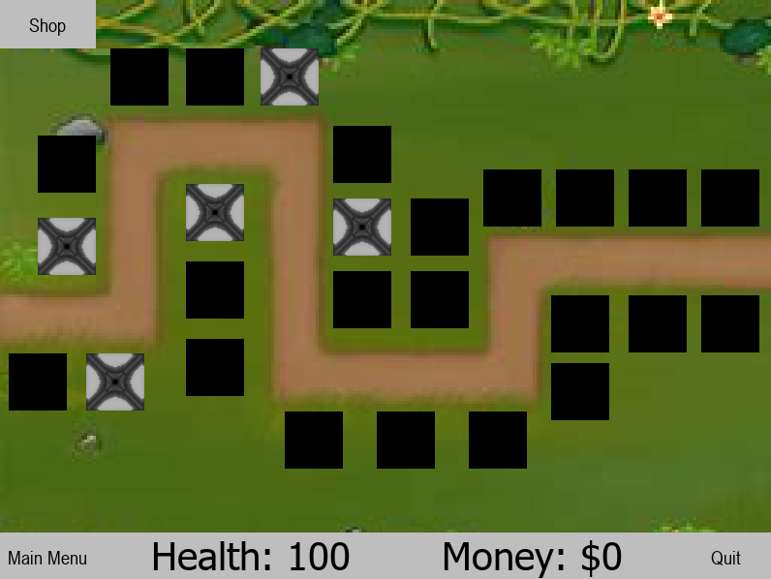

Fixing altered code with enemy waves – 13/04/24
Problem:
I altered the code which spawns in mobs for each wave to allow a delay between waves instead of creating multiple cooldown variables to check for each wave. In the process of doing this, I created an if statement which checks for when the mob_group is empty, and all enemies have been killed or deleted after reaching the end. Implementing this has caused the function to spawn a high amount of enemies constantly.
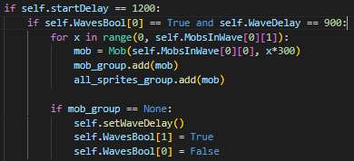
Remedial action:
To fix this I created a new a new variable in the player class called self.MobsSpawned which contains a list of Boolean values which are true if all the mobs in a wave have been spawned and False if they haven’t. Until the corresponding value has been changed to True, mobs will continue to be spawned in.
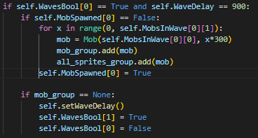
The code above is the changes ive made to the function. As the first wave hasn’t ended yet, this will be continuously looped through checking if the mob group is empty, and if it is then the wave will be ended and the delay in-between should start.

Test 15:
Test Number | Test | Expected Outcome | Actual Outcome | Pass/Fail
1 | Testing that the right number of enemies are spawned, a delay is added when they die, and the wave progresses to the next. | 6 enemies are spawned for the first wave and there is a 15 second wait before the next wave starts. | 6 enemies are spawned, and a delay occurs after the wave but the second wave never begins. | Fail

1st Wave – 6 mobs spawn: Delay after first wave:
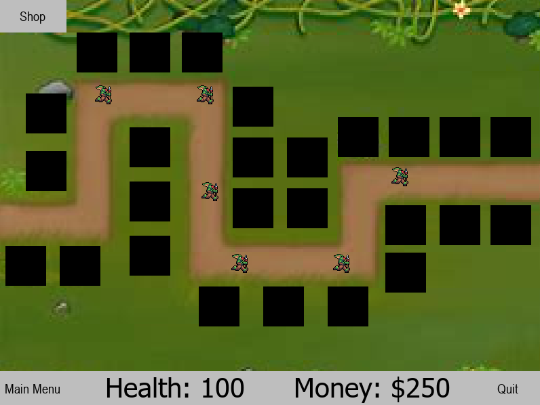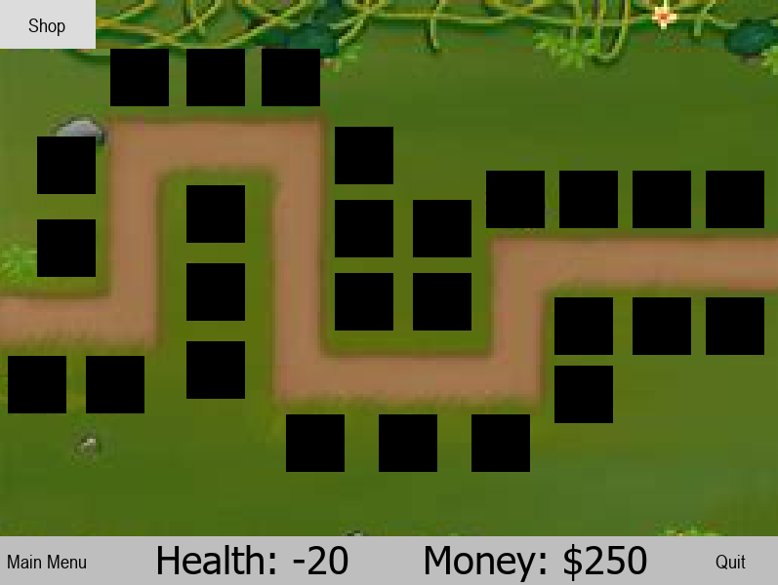

Remedial action:
In my previous changes to the function, I didn’t properly check if the group had no enemy sprites in it, using ‘if mob_group == None:’ won’t work as the group never becomes empty.
Instead, I need to check if its empty by checking if the length of the group is 0.
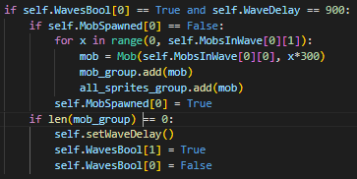

Test Number | Test | Expected Outcome | Actual outcome | Pass/Fail
2 | Testing that the right number of enemies are spawned, a delay is added when they die, and the wave progresses to the next. | 6 enemies are spawned for the first wave and there is a 15 second wait before the next wave starts. | 6 enemies are spawned, a time delay occurs between waves and the second wave starts. The wave 3, wave 4 etc… | Pass
6 mobs spawned in wave 1 Delay in between wave 1 and 2
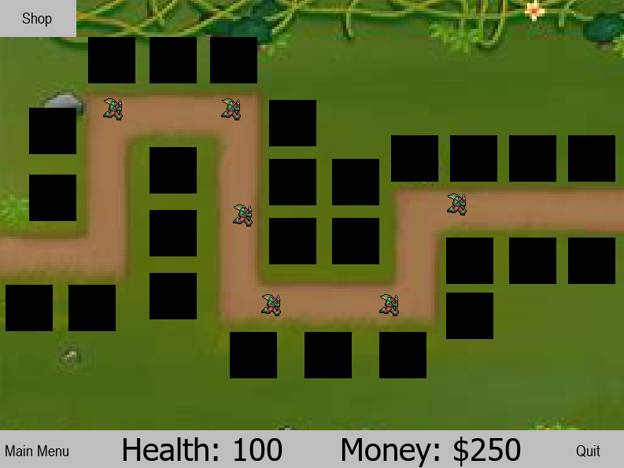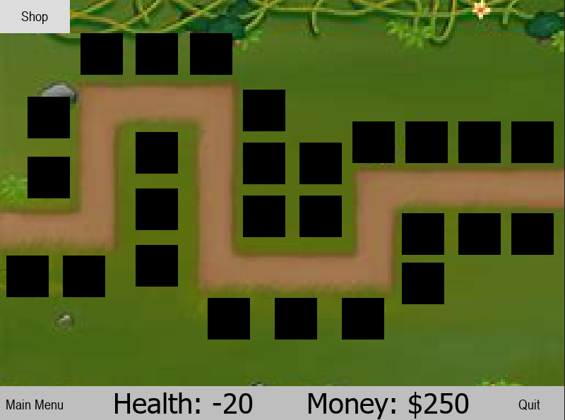
Wave 2 with all mobs spawning:
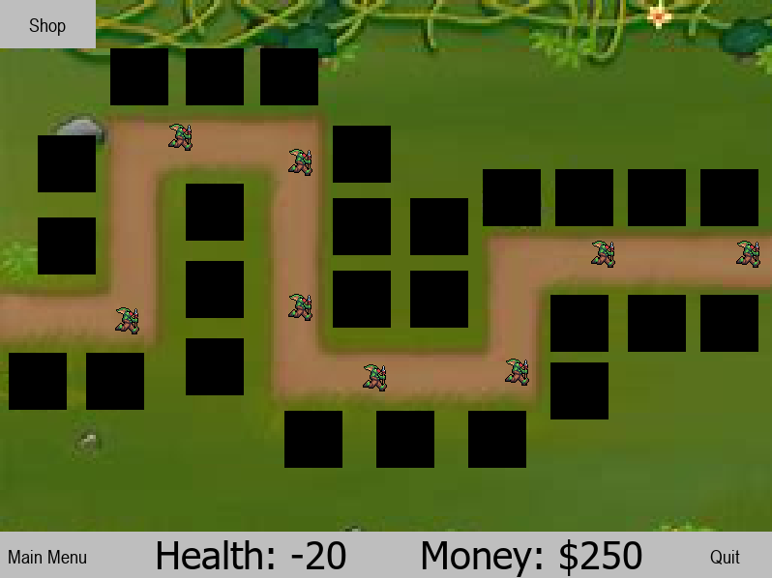

Usability testing
For tests 1-15 see pages 28 to 56

Test Number | test | Expected Outcome | Actual Outcome | Pass/Fail
16 | Testing enemies give the player $30 money when killed . | Money will increase by $180 for killing all enemies in wave 1. | Money increases by $180 after completing wave 1. | Pass
17 | Test that purchases take the correct money and work as intended. | Upgrades for range and damage are bought and their levels go up. Range will increase visibly; damage will cause enemies to die to 1 bullet. | Both upgrade buttons work properly, taking the correct money and increase by 1 level. Range visibly increases and damage increase causes enemy to die to 1 bullet. | Pass
18 | Clicking between the game and menu screen. | No progress will occur as the game is paused whilst on the menu screen. | No progress is made, bullets and enemies remain in the same position, the game is paused. | Pass
19 | Testing the accuracy of opening and closing the shop and upgrade shop. | Repeatedly clicking between the shop and upgrade shop for towers, whilst towers are selected to test that it functions as intended and only switches between the two. | No problems occurred whilst switching between the two menus, no bugs occurred. | Pass
20 | Testing repeatedly pressing buttons in the upgrade shop. | No upgrades should be applied to the towers. | No upgrades are applied. | Pass
21 | Going back and forth between the menu and the game as quickly as possible to assess for any bugs that effect the unpausing of the game. | No bugs occur, the game is just repeatedly paused and un-paused, and the functionality of the game after is not affected. | No problems with the game occur after repeatedly pausing an un-pausing. | Pass
22 | Testing what happens if the player “wins” when all enemies are deleted or killed, and the player dies at the same time. | The You lose message will be shown as the code checks if the player loses and runs the end function before checking for a win. | The “You Lose!” message pops up on the screen. | Pass
23 | Playing the game as intended to ensure the game functions as designed. | No errors occur, each function of the game works as intended without problem. | No errors occur as the game is played normally, for the experience of a normal player they will have an easy and entertaining experience. | Pass
24 | Making sure towers are only placed when the mouse button is clicked and not when the left mouse button is held. | Left mouse button is held and dragged across the placement blocks on the map. The blocks don’t change colour and no towers are placed. | No blocks change colour, and no towers are placed when the mouse is dragged across. | Pass

Success criteria

Success Criteria | Has it been met? | Reasoning
Must have 3 buttons, Play, scoreboard and quit, which both work and take the user to the desired place or complete the desired action. There will be a background image on the menu and text showing the name of the game. | This has not been fully met as the scoreboard was removed from the design as my stakeholders thought it wouldn’t be necessary to have one, Instead, two buttons appear on the menu screen, play and quit. The player can navigate between the game and the menu with ease and no bugs occurring.  This has been tested by me and my stakeholders to ensure no problems occur with it and it’s easy to use. | When the code is run, a main menu appears as the first part of the program where the player can select the play or quit buttons. The quit button stops the code running and closes the program whilst the play button runs the game loop and starts the game. The main menu can be accessed through a main menu button on the UI whilst the game is being played.
The onscreen UI will be on the edge of the screen and fully interactable to select options involving towers to be placed on the map. The UI will possibly popup when selected on the map and be closable. | This has been met as a shop button is placed in the top left of the game window, which when clicked opens the shop at the bottom of the screen.  This has been tested by me and my stakeholders multiple times, to ensure it functions as desired and doesn’t create any bugs when colliding with other features of the game. | The shop button can be clicked in the top left of the screen, which opens the shop as a bar across the bottom of the screen giving the player the ability to buy towers.
All counters will be displayed onscreen with a related icon next to the counter, only the round counter will be saved to the disk to be displayed on the scoreboard feature in the main menu. | This has been partially met, as there is no longer a time counter and wave counter, and the values of these counters are no longer saved and displayed on a scoreboard. There was not enough time to implement a wave counter into the design, this makes no effect to the functionality of the program.  Elliot and Johnny as my stakeholders thought that having a time count would have no use as the scoreboard was also removed. | Counters for player health and money are all placed on a UI at the bottom of the screen and change in real time with any purchases or health lost.
Towers will have clickable icons on the UI which are selected when clicked changing the button colour and then can be placed by clicking a spot on the map | This has been partially met, as towers can be clicked in the shop to be placed but the icons of the towers were replaced with a button instead. | This was not implemented as there was a lack of space to fit the buttons and selected text aswell as an icon of the tower. Despite this, the buttons work properly, labelled with the type of tower and price, causing no change to the games overall function.
Bullets released from the towers will track towards the enemy and cause damage. | This has been fully met as a major function of the gameplay, with each tower consistently producing bullets which act as desired. | The bullets were implemented to work as they are described but the algorithm behind how they function was changed. In theory, the bullets do not miss their target so using this, collision detection is not needed, and health can be taken straight from their target. This considerably decreased the complexity of the coding needed and made no impact to how the game runs.
The enemies will follow the set path on the map until it reaches the end. | This criterion has been met and enemies move along the set path from start to finish with no problems on the game map.  This has been trial and errored with my stakeholder Johnny, to determine the correct end points of each stretch of path, making sure the enemies stick to the path as they move. | In each wave, a set of enemies emerge from the start of the path on the left of level and traverse the path across the level to the end of the path where they move offscreen.
Once an enemy dies the money counter will be increased by a set amount and the enemy will be removed from the screen. | An enemy on the level will be deleted, and money will be added to the players money count displayed on the screen. | When an enemy has been dealt enough damage to reduce its health to 0, a method inside the mob class will add money to the attribute of the admin object (object of the player class), the inbuilt function self.kill() is then called in this method, and the enemy is deleted.
When an enemy reaches the end health will be taken from the player, lowering the health counter and removing the enemy from the screen. | An enemy will follow the fixed path for the level, and upon reaching the end will remove health from the player and remove the enemy from the screen.  Both my stakeholders agreed that 10 was a fair value of health to remove from the player. | An enemy follows the fixed path to the end and reaches the edge of the game window, where a method within the mob class is repeatedly called for every enemy created and takes 10 health from the player for the mob reaching the end and calls the self.kill() function which deletes the enemy.
Player will select a tower and upgrades will appear in the UI which can be clicked and take money from the player. | This feature works perfectly as intended, being ideal as a main feature in the game, bringing the Upgrade shop UI onto the bottom of the screen.  This has been tested by both my stakeholders Johnny and Elliot, to test the functionality in all possible cases the player may find themselves in when bringing the UI up. | When a placed tower is clicked and it shows as selected, a UI will appear at the bottom of the screen in the same place as the shop with buttons which can be pressed to purchase upgrades for the towers.
When enough enemies have reached the end of the path, and the players health drops to 0, a win or lose message must appear on the screen with a quit button below it. | This feature works as desired where a grey box will appear with text saying, “You Win!” or “You Lose!” depending on the situation.  This was designated as an important feature by my stakeholders, Johnny and Elliot as they thought it was needed to reduce confusion with the player when the main game loop is executed when the player loses or wins. | When the players health hits 0, the game loop will stop running and a grey box will appear on the screen with text saying, “You Lose!”. The Quit button remains in the bottom right of the screen for the player to exit out of the game.  If the player completes all 10 waves, then the game loop is executed and a grey box will appear with text saying “You Win!”, again with the quit button still in the bottom right so the player can quit the game.
Everything displayed onscreen will move independently of each other and will all move at the same time. | Multiple entities can be in use in the game and each run independently of each other. | Multiple towers can be placed all over the level, as well as multiple enemies being spawned in at the same time for each wave. All the processes of entity are run individually so they all function independently of each other and don’t interfere with each other and effect the overall functionality of the code.
The game will have an option to select a game difficulty after the play button has been clicked. | This has not been met as it was too complex to implement and there wasn’t enough time to change all the games functionality based on the game difficulty picked.  My stakeholders agree that this should have been left out as the program would have to be completely altered to add a difficulty feature and would have taken too long to complete. | No difficulty feature was added for when the play button is clicked. The difficulty remains the same every time the game is played, and enemy speed, player health and enemy health will remain the same and not scale based on difficulty.

future development and Maintanace

Number | Future addition | Explanation
1 | More Levels | Currently the game only allows for 1 map to be played so the game stays simple, so as a future development more levels could be added.
2 | More enemies | To reduce the complexity of the code and game for the players only 2 types of enemies were implemented, in the future more enemy types could be added which utilize different movement speeds, health, size and a different amount of health taken from the user.
3 | More towers | Only two types of towers were added to the game to reduce the complexity of the game and reduce confusion for the players playing it. In the future more types of towers can be added, changing the cooldown between firing and the damage the towers due to the enemies.
4 | Better designs and animations | Due to the games simplistic design, the animations of the enemies and towers were simplified, for example enemies could have a running animation as they move across the screen, and towers could have better designs. This could also include designs for the bullets towers produce, changing them to actual bullets or arrows.
5 | Sound | A potential future development could include sound effects and music, for towers shooting, placement an upgrading as well as music that is different for when the main menu is up, the game is being played and the end screen is up.
6 | Scoreboard | A scoreboard could be added, like what was in the original design for my game which keeps track of your wins and losses on each map.
7 | Storyline | A possible long tern future development for this game could be adding a storyline, which links together multiple levels, unlocking the next level after the previous one has been completed.
8 | Difficulty | Changeable game difficulty is a future addition to the game which will add a new depth to the game regardless of how many levels have been implemented. This will allow players to challenge themselves on a hard difficulty or play on easy difficulty and learn to play the game.

Project Appendixes

#####################library files########################
import math
import os
import time
import pygame

abspath = os.path.abspath(__file__)
dname = os.path.dirname(abspath)
################this inistialises the pygame settings##########################

pygame.init()

#set up screen dimensions
display_width = 800
display_height = 600
FPS = 60

gameDisplay = pygame.display.set_mode((display_width,display_height))
clock = pygame.time.Clock() ### this enables us to set frame rate

#colour constants for button backgrounds and screen backgrounds
BLACK = (0,0,0)
WHITE = (255,255,255)

RED = (200,0,0)
GREEN = (0,200,0)
YELLOW = (255,255,0)
BLUE = (0,0,255)
BRIGHT_RED = (255,0,0)
BRIGHT_GREEN = (0,255,0)
LIGHT_YELLOW = (255,255,51)
BUTTON_HOVER = (220,220,220)

AQUA = (0, 128, 128)
AQUA1 = (0, 115, 115)
GRAY = (190, 190, 190)
SHOP = (180, 180, 180)

# Game Variables
playerHealth = 100
Op1 = False
Op2 = False
Cl1 = False
Cl2 = False
Fate = None

Ts = "None selected" # text for which tower type is selected
TSx = 1000
TSy = 1000
TowerNum = 0

# X and Y coordinates for the buttons in the shop.
clicked1 = 0
Bx1, By1, Bw1, Bh1 = 1000, 1000, 200, 80
Bx2, By2, Bw2, Bh2 = 1000, 1000, 200, 80
B1P = 0

UBx1, UBy1, UBw1, UBh1 = 1000, 1000, 200, 80
UBx2, UBy2, UBw2, UBh2 = 1000, 1000, 200, 80
B1Cooldown = 10
B2Cooldown = 10

# Variables for the upgrade bar

# Variables for clicking the 2nd tower button
clicked2 = 0
Cl21 = False
Cl22 = False

#
Tclicked = 0
TCl1 = False
TCl2 = False

# determines what type of tower is placed --- can be 1 or 2
ActType = 0
SelRngLvl = 0
SelDmgLvl = 0

#this is for text boxes on the screens i.e. titles etc

def text_objects(text, font):
textSurface = font.render(text, True, BLACK)
return textSurface, textSurface.get_rect()

# this creates our buttons parameters text, x position, y position, width of button, height of button, colour, hover colour, function to run.

def button(msg,x,y,w,h,ic,ac,action=None):

mouse = pygame.mouse.get_pos()
click = pygame.mouse.get_pressed()

# check position and draw the rectangle - takes the screen we set up gameDisplay. We will need to amend if using multiple screens

if x+w > mouse[0] > x and y+h > mouse[1] > y:
pygame.draw.rect(gameDisplay, ac,(x,y,w,h))
if click[0] == 1 and action != None:
action()
else:
pygame.draw.rect(gameDisplay, ic,(x,y,w,h))
smallText = pygame.font.SysFont("arial",20)
textSurf, textRect = text_objects(msg, smallText)
textRect.center = ( (x+(w/2)), (y+(h/2)) )
gameDisplay.blit(textSurf, textRect)

##################################################################################################################################################################
##################################################################################################################################################################

class bullet(pygame.sprite.Sprite):
def __init__(self, pos_x, pos_y, rel_x, rel_y):
super().__init__()
self.image = pygame.Surface((10, 10))
self.image.fill(BLACK)
self.rect = self.image.get_rect(center=(pos_x+25, pos_y+25))
self.x_move, self.y_move = rel_x, rel_y

def update(self,):
self.rect.x += self.x_move * 20 #due to rsin(theta) and rcos(theta)
self.rect.y += self.y_move * 20

def deleteB(self):
if self.rect.x >= 800 or self.rect.x <= 0 or self.rect.y >= 600 or self.rect.y <= 0:
self.kill()
##################################################################################################################################################################

class Tower(pygame.sprite.Sprite):
def __init__(self, Type, x, y, name):
super().__init__()
pygame.sprite.Sprite.__init__(self)
self.image = pygame.Surface((60,60))
self.rect = self.image.get_rect(center = (x,y))
self.rect.x = x
self.rect.y = y
self.key_time = 10
self.cooldown = 120
self.range = 120
self.type = Type
self.visibility = 100
self.Tselected = False
self.TselectTime = 10
self.name = "Tower" + name
self.RangeLevel = 0
self.DamageLevel = 0
self.DmgBase = 5
self.damage = 5

if self.type == 1:
self.image = pygame.image.load(dname + "/tower-type-1.png")
self.DmgBase = 5
if self.type == 2:
self.image = pygame.image.load(dname + "/tower-type-2.png")
self.DmgBase = 7
self.range = 90

#range image
self.range_image = pygame.Surface((self.range * 2, self.range*2))
self.range_image.fill((0,0,0))
self.range_image.set_colorkey((0,0,0))
pygame.draw.circle(self.range_image, "grey", (self.range, self.range), self.range)
self.range_image.set_alpha(self.visibility)
self.range_rect = self.range_image.get_rect()
self.range_rect.x = x
self.range_rect.y = y
self.range_rect.center = self.rect.center

def UpgradeDamage(self):
if Admin.getMoney() >= (30 + self.DamageLevel * 30):
Admin.TakeMoney(30 + self.DamageLevel * 30)
self.DamageLevel += 1
self.damage = 7 + (self.DamageLevel * self.DmgBase)

def UpgradeRange(self):
if Admin.getMoney() >= (60 + self.RangeLevel * 60):
Admin.TakeMoney(60 + self.RangeLevel * 60)
self.RangeLevel += 1
self.range = self.range + (10*self.RangeLevel)
self.range_image = pygame.Surface((self.range * 2, self.range*2))
self.range_image.fill((0,0,0))
self.range_image.set_colorkey((0,0,0))
pygame.draw.circle(self.range_image, "grey", (self.range, self.range), self.range)
self.range_image.set_alpha(self.visibility)
self.range_rect = self.range_image.get_rect()
self.range_rect.x = self.rect.x
self.range_rect.y = self.rect.y
self.range_rect.center = self.rect.center

def getRngLvl(self):
return self.RangeLevel

def getDmgLvl(self):
return self.DamageLevel

# functions for cooldown of shooting
def getCooldown(self):
return self.cooldown

def setCooldown(self):
self.cooldown = 120

def ChangeCooldown(self):
self.cooldown += 1

# draws the range for the towers
def drawR(self, surface):
surface.blit(self.range_image, self.range_rect)

# functions for selection of towers
def getSelected(self):
return self.Tselected

def setSelectedT(self):
self.Tselected = True
self.range_image.set_alpha(100)

def setSelectedF(self):
self.Tselected = False
self.range_image.set_alpha(0)

# gets the coordinates of the towers
def getX(self):
return self.rect.x

def getY(self):
return self.rect.y

# sets the colour for the type of tower
def set(self):
if self.type == 1:
self.range_image.fill(RED)
if self.type == 2:
self.range_image.fill(BLUE)

# functions for placemment time delay
def GetTime(self): # returns the value of the time delay
return self.key_time

def ChangeTime(self): # decrease by 1 per tick
self.key_time -= 1

def setTime(self): # set back to original
self.key_time = 10

# for updating the tower
def updateT(self, mob_group):
if self.cooldown == 120:
self.pick_target(mob_group)
self.cooldown = 0
self.target = None

# for picking a mob within range
def pick_target(self, mob_group):
# find a mob for the tower to target within range
x_dist = 0
y_dist = 0
# check distance to each enemy to see if it is within range
for mob in mob_group:
x_dist = mob.getX() - self.rect.x
y_dist = mob.getY() - self.rect.y
dist = math.sqrt(x_dist ** 2 + y_dist ** 2)
if dist < self.range:
self.target = mob
print("Target Picked:", mob)
mob.TakeHealth(self.damage)
bulletgroup.add(self.bullet(mob.getX(), mob.getY()))
break

def bullet(self, mobx, moby):
# Ensure camera stays within the boundaries of the game world
self.rel_x, self.rel_y = mobx - self.rect.x, moby - self.rect.y # self.relx/y will be cooridnates of mob on map
distance=math.hypot(self.rel_x, self.rel_y)
if distance==0:
self.rel_x,self.rel_y =0 ,0
else:
self.rel_x , self.rel_y = self.rel_x/distance , self.rel_y/distance
print("shot")
return bullet(self.rect.x,self.rect.y,self.rel_x,self.rel_y)

##################################################################################################################################################################
##################################################################################################################################################################

class Mob(pygame.sprite.Sprite):
walkright = [pygame.image.load(dname + "/Goblin_run_right.gif")] # Mob images for walking in different directions

# constructor
def __init__(self, Mtype, offset, WaveScale):
super().__init__()
pygame.sprite.Sprite.__init__(self) # calls constructor of parent class
self.image = pygame.image.load(dname + "/Goblin_run_right.gif").convert_alpha()
self.rect=self.image.get_rect(center =(16,331))
self.rect.x= 0 - offset # set x position
self.rect.y= 315 # set y position
self.xholder = 0
self.path = [self.rect.x, 125, 125, 296, 375, 520, 245, 805]
self.pathT = [True, False, False, False, False, False, False, False]
self.vel= 5 # sets x and y speeds for the mobs
self.dmg = 0
self.MobType = Mtype
self.health = 10
self.healthLevel = 0

if self.MobType == 1:
self.health = 10 + (10 * WaveScale)
self.vel = 2
self.dmg = 10

def drawP(self): # draws the mob on screen
self.move()

def move(self): # moves the mob along a set path
if self.vel > 0:
if self.pathT[0]:
if self.rect.x + self.vel <self.path[1]:
self.rect.x += self.vel
else:
self.pathT[1] = True
self.pathT[0] = False

if self.pathT[1]:
self.xholder = self.rect.x
if self.rect.y - self.vel > self.path[2]:
self.rect.y -= self.vel
else:
self.pathT[2] = True
self.pathT[1] = False

if self.pathT[2]:
self.xholder = self.rect.x
if self.rect.x + self.vel < self.path[3]:
self.rect.x += self.vel
else:
self.pathT[3] = True
self.pathT[2] = False

if self.pathT[3]:
self.xholder = self.rect.x
if self.rect.y + self.vel < self.path[4]:
self.rect.y += self.vel
else:
self.pathT[4] = True
self.pathT[3] = False

if self.pathT[4]:
if self.rect.x + self.vel < self.path[5]:
self.rect.x += self.vel
else:
self.pathT[5] = True
self.pathT[4] = False

if self.pathT[5]:
if self.rect.y - self.vel > self.path[6]:
self.rect.y -= self.vel
else:
self.pathT[6] = True
self.pathT[5] = False
if self.pathT[6]:
if self.rect.x + self.vel < self.path[7]:
self.rect.x += self.vel
else:
self.pathT[6] = False

def checkHealth(self):
if self.health <= 0:
if self.MobType == 1:
Admin.GiveMoney(30)
self.kill()

def TakeHealth(self, dmg):
self.health -= dmg
print(self.health)

def getX(self):
return self.rect.x

def getY(self):
return self.rect.y

def End(self):
if self.rect.x >= 800:
Admin.take_health1(self.dmg)
self.kill()

##################################################################################################################################################################

class PlacementBlock(pygame.sprite.Sprite):
def __init__(self,x,y):
pygame.sprite.Sprite.__init__(self)
self.image = pygame.Surface((60,59))
self.rect = self.image.get_rect()
self.rect.x = x
self.rect.y = y
self.clicked = 0
self.key_time = 10 # time delay
self.type = 0 # type of tower
self.action = None # which tower type is selected
self.lock = 0 # locks block so tower type cant be changed
self.TowPlc = False # tower placed

def getTowPlc(self):
return self.TowPlc

def setTowPlc(self):
self.TowPlc = True

def getClicked(self):
return self.clicked

def getX(self):
return self.rect.x

def getY(self):
return self.rect.y

def getType(self):
return self.type

def pressed(self, actionType): # will check if a placeable spot has been clicked
self.action = actionType
Flag = ShopScreen.GetFlag()
click = pygame.mouse.get_pressed()
pos = pygame.mouse.get_pos()
if Flag: # checks that the shop is open before a placement block can be selected
if self.clicked == 0: # checks if it has been clicked on before
if self.key_time != 0: # creates a time delay between processed clicks
self.key_time -= 1
if self.key_time == 0: # checks that the delay has ended before the box can be clicked
if pos[0] < self.rect.x and pos[1] < self.rect.y or pos[0] > (self.rect.x + 50) and pos[1] > (self.rect.y + 50): # if the mouse is outside the box
if click[0]: # if the left mouse button is clicked
click = False # sets the boolean value for left mouse click to false
if (pos[0] >= self.rect.x and pos[1] >= self.rect.y) and (pos[0] <= (self.rect.x + 50) and pos[1] <= (self.rect.y + 50)): # if the mouse is inside the box
if (self.action == 1 and Admin.getMoney() >= 50) or (self.action == 2 and Admin.getMoney() >= 60):
if click[0]: # checks if the left mouse button has been clicked
print("block clicked")
self.key_time = 20 #resets the time delay
self.clicked = 1 # sets clicked to 1 to show it has been clicked and used
else:
pass
else:
pass

if self.lock == 0: # checks if the box has been locked to a type of tower
if self.clicked == 1: # checks box has been clicked
if self.action == 1: # if tower type is 1
self.image.fill(AQUA) # sets box colour to blue
self.lock = 1
if self.action == 2: # if tower type is 2
self.image.fill(GREEN) # sets box colour to green
self.lock = 1

##################################################################################################################################################################

class ScreenBar(pygame.sprite.Sprite):
def __init__(self, width, height, x, y):
pygame.sprite.Sprite.__init__(self)
self.image = pygame.Surface((width,height))
self.image.fill(GRAY)
self.rect = self.image.get_rect()
self.UP = 0
self.rect.x = x
self.rect.y = y

##################################################################################################################################################################

class ShopBar(pygame.sprite.Sprite):
global Bx1, By1, Bw1, Bh1, Op1, Op2
global Bx2, By2, Bw2, Bh2, TSx, TSy, ActType
def __init__(self): # defines private attributes
pygame.sprite.Sprite.__init__(self)
self.image = pygame.Surface((800,100))
self.image.fill(SHOP)
self.rect = self.image.get_rect()
self.Status = 0
self.Ustatus = 0
self.rect.x = 0
self.rect.y = 1000
self.key_time = 10
self.Flag = False

def GetTime(self): # returns the value of the time delay
return self.key_time

def ChangeTime(self): # decrease by 1 per tick
self.key_time -= 1

def setTime(self): # set back to original
self.key_time = 10

def GetStatus(self): # returns whether shop is shown or hidden
return self.Status

def SetStatus(self, status): # sets shop to shown or hidden
self.Status = status

def hideShop(self): # hides the shop in game
if self.Status == 1:
print("Works to Hide")
self.rect.y = 1000
self.Status = 0 # shows the shop has been hiden

def ShowShop(self): # shows the shop in game
if self.Status == 0:
print("Works to show")
self.rect.y = 450
self.Status = 1 # shows the shop has been moved onto the screen

def SetFlag1(self): # sets a flag variable true to say the shop has been used
self.Flag = True

def SetFlag2(self): # sets the flag variable to false to show the shop has been closed
self.Flag = False

def GetFlag(self):
return self.Flag

def ShowUpgrade(self):
self.rect.y = 450

def HideUpgrade(self):
self.rect.y = 1000

##################################################################################################################################################################
##################################################################################################################################################################

class Player(pygame.sprite.Sprite):
# constructor
def __init__(self):
pygame.sprite.Sprite.__init__(self) # calls constructor of parent class
self.health = 100
self.money = 250
self.key_time = 10
self.PlacementTime = 1
self.MobsInWave = [[1,6], [1,10], [1,10], [1,20], [1,25], [1,30], [1,35], [1,35], [1,45], [1,50]]
self.WavesBool = [True,False,False,False,False,False,False,False,False,False]
self.MobSpawned = [False,False,False,False,False,False,False,False,False,False]
self.WaveDelay = 900
self.startDelay = 0

def waves(self):
if self.startDelay == 1200:
if self.WavesBool[0] == True and self.WaveDelay == 900:
if self.MobSpawned[0] == False:
for x in range(0, self.MobsInWave[0][1]):
mob = Mob(self.MobsInWave[0][0], x*300, 0)
mob_group.add(mob)
all_sprites_group.add(mob)
self.MobSpawned[0] = True
if len(mob_group) == 0:
self.setWaveDelay()
self.WavesBool[1] = True
self.WavesBool[0] = False

if self.WavesBool[1] == True and self.WaveDelay == 900:
if self.MobSpawned[1] == False:
for x in range(0,self.MobsInWave[1][1]):
mob = Mob(self.MobsInWave[1][0], x*300, 1)
mob_group.add(mob)
all_sprites_group.add(mob)
self.MobSpawned[1] = True
if len(mob_group) == 0:
self.setWaveDelay()
self.WavesBool[2] = True
self.WavesBool[1] = False

if self.WavesBool[2] == True and self.WaveDelay == 900:
if self.MobSpawned[2] == False:
for x in range(0,15):
mob = Mob(self.MobsInWave[2][0], x*300, 2)
mob_group.add(mob)
all_sprites_group.add(mob)
self.MobSpawned[2] = True

if len(mob_group) == 0:
self.setWaveDelay()
self.WavesBool[3] = True
self.WavesBool[2] = False

if self.WavesBool[3] == True and self.WaveDelay == 900:
if self.MobSpawned[3] == False:
for x in range(0,self.MobsInWave[3][1]):
mob = Mob(self.MobsInWave[3][0], x*300, 3)
mob_group.add(mob)
all_sprites_group.add(mob)
self.MobSpawned[3] = True
if len(mob_group) == 0:
self.setWaveDelay()
self.WavesBool[4] = True
self.WavesBool[3] = False

if self.WavesBool[4] == True and self.WaveDelay == 900:
if self.MobSpawned[4] == False:
for x in range(0,self.MobsInWave[4][1]):
mob = Mob(self.MobsInWave[4][0], x*300, 4)
mob_group.add(mob)
all_sprites_group.add(mob)
self.MobSpawned[4] = True
if len(mob_group) == 0:
self.setWaveDelay()
self.WavesBool[4] = False

if self.WavesBool[5] == True and self.WaveDelay == 900:
if self.MobSpawned[5] == False:
for x in range(0,self.MobsInWave[5][1]):
mob = Mob(self.MobsInWave[5][0], x*300, 5)
mob_group.add(mob)
all_sprites_group.add(mob)
self.MobSpawned[5] = True
if len(mob_group) == 0:
self.setWaveDelay()
self.WavesBool[5] = False

if self.WavesBool[6] == True and self.WaveDelay == 900:
if self.MobSpawned[6] == False:
for x in range(0,self.MobsInWave[6][1]):
mob = Mob(self.MobsInWave[6][0], x*300, 6)
mob_group.add(mob)
all_sprites_group.add(mob)
self.MobSpawned[6] = True
if len(mob_group) == 0:
self.setWaveDelay()
self.WavesBool[6] = False

if self.WavesBool[7] == True and self.WaveDelay == 900:
if self.MobSpawned[7] == False:
for x in range(0,self.MobsInWave[7][1]):
mob = Mob(self.MobsInWave[7][0], x*300, 7)
mob_group.add(mob)
all_sprites_group.add(mob)
self.MobSpawned[7] = True
if len(mob_group) == 0:
self.setWaveDelay()
self.WavesBool[7] = False

if self.WavesBool[8] == True and self.WaveDelay == 900:
if self.MobSpawned[8] == False:
for x in range(0,self.MobsInWave[8][1]):
mob = Mob(self.MobsInWave[8][0], x*300, 8)
mob_group.add(mob)
all_sprites_group.add(mob)
self.MobSpawned[8] = True
if len(mob_group) == 0:
self.setWaveDelay()
self.WavesBool[8] = False

if self.WavesBool[9] == True and self.WaveDelay == 900:
if self.MobSpawned[9] == False:
for x in range(0,self.MobsInWave[9][1]):
mob = Mob(self.MobsInWave[9][0], x*300, 9)
mob_group.add(mob)
all_sprites_group.add(mob)
self.MobSpawned[9] = True
if len(mob_group) == 0:
self.setWaveDelay()
self.WavesBool[9] = False

def GetMobSpawned(self):
return self.MobSpawned

def setWaveDelay(self):
self.WaveDelay = 0

def ChangeWaveDelay(self):
self.WaveDelay += 1

def getWaveDelay(self):
return self.WaveDelay

def getStartDelay(self):
return self.startDelay

def changeStartDelay(self):
self.startDelay += 1

def SetPT(self):
self.PlacementTime = 0

def GetPT(self):
return self.PlacementTime

def ChangePT(self):
self.PlacementTime += 1

def take_health1(self, amount): # takes 5 health from player once mob reaches end of path
self.health -= amount

def get_health(self): # returns the value of the players health
return self.health

def getMoney(self): # returns the amount of money the player has
return self.money

def GiveMoney(self, amount): # gives money to the player
self.money += amount

def TakeMoney(self, amount): # takes money from the player
self.money -= amount

def GetTime(self): # returns the value of the time delay
return self.key_time

def ChangeTime(self): # decrease by 1 per tick
self.key_time -= 1

def setTime(self): # set back to original
self.key_time = 10

# creates the screen area - will need one for each screen when using background images to be done next
# gamedisplay is the screen area where we draw things to from now on

############################################################################# --- This instanciates the blocks onscreen that represent where towers can be placed.
##################################################################################################################################################################

all_sprites_group = pygame.sprite.Group() # sprite group to hold everything

BlockPos = [[40,225],[10,365],[90,365],[193,270],[193,190],[40,140],[115,50],[193,50],[270,50],[345, 130],[345, 205],[345, 280],[425, 280],[193,350],
[295, 425], [390,425], [485,425], [570,305], [570, 375], [650,305], [725, 305], [575, 175], [650, 175], [725, 175], [500, 175], [425, 205]]
block_group = pygame.sprite.Group()
for x in range(0, len(BlockPos)):
block = PlacementBlock(BlockPos[x][0], BlockPos[x][1])
block_group.add(block)
all_sprites_group.add(block)

Admin = Player()

Bar = ScreenBar(800, 50, 0, 550) # grey bar at the bottom of the screen
ShopScreen = ShopBar() # grey bar that appears when the shop button is pressed
UpgradeScreen = ShopBar() # grey bar that apprears for tower upgrades
Shop_group = pygame.sprite.Group()
all_sprites_group.add(Bar)
Shop_group.add(ShopScreen)
Shop_group.add(UpgradeScreen)

bulletgroup = pygame.sprite.Group() #
towergroup = pygame.sprite.Group() # group containing all towers placed

mob_group=pygame.sprite.Group()

##################################################################################################################################################################
##################################################################################################################################################################

# Brings up the Game shop

def UpgradeShop():
global Bx1, By1, Bw1, Bh1, Op1, Op2
global Bx2, By2, Bw2, Bh2, TSx, TSy, ActType
global UBx1, UBy1, UBx2, UBy2
status = ShopScreen.GetStatus()

for tower in towergroup:

if tower.getSelected() == True and status == 0:
UpgradeScreen.ShowUpgrade()
print("gets to here")
UBx1 = 50
UBy1 = 460
UBx2 = 550
UBy2 = 460
break

if tower.getSelected() == True and status == 1:
ShopScreen.hideShop()
UpgradeScreen.ShowUpgrade()
Op2 = True
Bx1 = 1000
By1 = 1000
Bx2 = 1000
By2 = 1000
TSx = 1000
TSy = 1000
UBx1 = 50
UBy1 = 460
UBx2 = 550
UBy2 = 460
ActType = 0
ShopScreen.SetFlag2()
break

if tower.getSelected() == False:
print("does this")
for tower2 in towergroup:
if tower2.getSelected() == True:
UpgradeScreen.HideUpgrade()
UpgradeScreen.HideUpgrade()
ShopScreen.hideShop()
Op2 = True
Bx1 = 1000
By1 = 1000
Bx2 = 1000
By2 = 1000
TSx = 1000
TSy = 1000
UBx1 = 1000
UBy1 = 1000
UBx2 = 1000
UBy2 = 1000
ActType = 0
ShopScreen.SetFlag2()

def Shop():
global Bx1, By1, Bw1, Bh1, Op1, Op2
global Bx2, By2, Bw2, Bh2, TSx, TSy, ActType
global UBx1, UBy1, UBx2, UBy2
status = ShopScreen.GetStatus()
time = ShopScreen.GetTime()

if status == 0 and time == 10:

ShopScreen.ShowShop()
UpgradeScreen.HideUpgrade()
Op1 = True
Bx1 = 50
By1 = 460
Bx2 = 550
By2 = 460
TSx = 400
TSy = 500
UBx1 = 1000
UBy1 = 1000
UBx2 = 1000
UBy2 = 1000
ActType = 0
ShopScreen.SetFlag1()

for tower in towergroup:
tower.setSelectedF()

if status == 1 and Op1 == False and time == 10:

ShopScreen.hideShop()
UpgradeScreen.HideUpgrade()
Op2 = True
Bx1 = 1000
By1 = 1000
Bx2 = 1000
By2 = 1000
TSx = 1000
TSy = 1000
UBx1 = 1000
UBy1 = 1000
UBx2 = 1000
UBy2 = 1000
ActType = 0
ShopScreen.SetFlag2()

for tower in towergroup:

tower.setSelectedF()

def Tw1():
global clicked1, Cl1, Cl2, ActType, clicked2
time = Admin.GetTime()
if clicked1 == 1 and time == 10:

clicked1 = 0
Cl1 = True
ActType = 0
print(clicked1)

else:

if time == 10:

clicked1 = 1
clicked2 = 0
Cl2 = True
ActType = 1
print(clicked1)

def Tw2():

global clicked2, Cl21, Cl22, ActType, clicked1
time = Admin.GetTime()

if clicked2 == 2 and time == 10:

clicked2 = 0
Cl21 = True
ActType = 0
print(clicked2)

else:

if time == 10:

clicked2 = 2
clicked1 = 0
Cl22 = True
ActType = 2
print(clicked2)

def UpgradeDmg():
global B1Cooldown
for tower in towergroup:
if tower.getSelected() == True and B1Cooldown == 10:
tower.UpgradeDamage()
B1Cooldown = 0

def UpgradeRng():
global B2Cooldown
for tower in towergroup:
if tower.getSelected() == True and B2Cooldown == 10:
if tower.getRngLvl() < 5:
tower.UpgradeRange()
B2Cooldown = 0

# main menu screen

def main_menu():
global intro, play, EndL
time.sleep(0.2)
intro = True #### will display until we set to false
play = False
EndL = False
Bg = pygame.image.load(dname + "/MMBG.jpg")
Bg = pygame.transform.scale(Bg,(display_width,display_height))
while intro:
for event in pygame.event.get():
# checks that we havent hit the x in the window
if event.type == pygame.QUIT:
pygame.quit()
quit()

#set our screen background colour (change to image here)
#gameDisplay.fill(WHITE)
gameDisplay.fill(GRAY)
gameDisplay.blit(Bg,(0,0))
#sets the text size and font for title -could be declared globally
largeText = pygame.font.SysFont("tahoma",50)
TextSurf, TextRect = text_objects("MAIN MENU", largeText)
#sets the position of title text - i just changed the display_height divided by for vertical position
TextRect.center = ((display_width/2),(display_height/5))
gameDisplay.blit(TextSurf, TextRect)

#call button function to create the buttons
# these buttons trigger different game states
button("Play",350,250,125,50,GRAY,BUTTON_HOVER,game_loop)
button("Quit",350,450,125,50,GRAY,BUTTON_HOVER,quitgame)

pygame.display.update()
clock.tick(FPS) ### set frame rate to 15

#main game loop - change your main game play loop to a procedure so that it runs from the button.

def game_loop():
global Op1, Op2, Cl1, Cl2, Cl21, Cl22, TCl1, TCl2
global Bx1, By1, Bw1, Bh1
global Bx2, By2, Bw2, Bh2, TSx, TSy, Ts
global ActType, TowerNum, SelDmgLvl, SelRngLvl
global UBx1, UBx2, UBy1, UBy2, UBw1, UBh1, UBw2, UBh2, B1Cooldown, B2Cooldown
global intro, Fate, play, EndL
intro = False

play = True
x = 0
Bg = pygame.image.load(dname + "/TowerDefencePath.jpg")
Bg = pygame.transform.scale(Bg,(display_width,display_height))

while play:
# Event Handler
for event in pygame.event.get():
# Quits the program when the window is closed.
if event.type == pygame.QUIT:
pygame.quit()
quit()

if event.type == pygame.MOUSEBUTTONDOWN and event.button == 1: # checks if the left mouse button has been clicked.
### Loop which will check whether a placement block has been clicked and place a tower if one was selected in the shop. ###
for block in block_group:
block.pressed(ActType)
if block.getClicked() == 1 and block.getTowPlc() == False: # checks that a tower type has been selected for placement, a block has been clicked and a tower hasn't already been placed in that spot.
if ActType == 1:
Admin.TakeMoney(50)
Xco = block.getX() # gets the x coordinate of the placement block
Yco = block.getY() # gets the y coordinate of the placement block
print(Xco,Yco)
TowerNum += 1 # adds 1 to a count variable for the no. of towers so a name can be assigned to each --> e.g. 'Tower1'
# sets all towers already placed, to have a selected variable of False.
for tower1 in towergroup: # loops through all the towers in the tower group.
tower1.setSelectedF() # sets the selected variable to false

tower = Tower(ActType, Xco, Yco, str(TowerNum))# instanciates an object of the tower class to be placed on a tower block.
towergroup.add(tower) # adds the placed tower to the tower group.
all_sprites_group.add(tower) # adds the placed tower to the group of all sprites.
block.setTowPlc() # sets it so that the block knows a tower has been placed there so another can't be.
Admin.SetPT() # resets the place time delay
break # breaks out of the loop.
if ActType == 2:
Admin.TakeMoney(60)
Xco = block.getX() # gets the x coordinate of the placement block
Yco = block.getY() # gets the y coordinate of the placement block
print(Xco,Yco)
TowerNum += 1 # adds 1 to a count variable for the no. of towers so a name can be assigned to each --> e.g. 'Tower1'
# sets all towers already placed, to have a selected variable of False.
for tower1 in towergroup: # loops through all the towers in the tower group.
tower1.setSelectedF() # sets the selected variable to false

tower = Tower(ActType, Xco, Yco, str(TowerNum))# instanciates an object of the tower class to be placed on a tower block.
towergroup.add(tower) # adds the placed tower to the tower group.
all_sprites_group.add(tower) # adds the placed tower to the group of all sprites.
block.setTowPlc() # sets it so that the block knows a tower has been placed there so another can't be.
Admin.SetPT() # resets the place time delay
break # breaks out of the loop.

### Checks whether a tower has been clicked to select/deselect it. ###
for tower in towergroup: # loops through all the placed towers in the tower group
Tx = tower.getX() # gets the x coordiante of each tower
Ty = tower.getY() # gets the y coordinate of each tower
pos = pygame.mouse.get_pos() # gets the position of the mouse
### code to deselect a tower onscreen. ###
if tower.getSelected() == True and Admin.GetPT() == 1: # checks if the tower has already been selected
if (pos[0] >= Tx and pos[1] >= Ty) and (pos[0] <= (Tx + 50) and pos[1] <= (Ty + 50)): # checks if the mouse position is within the boundaries of a placement block
tower.setSelectedF() # calls the false selected function to set the selected attribute to False
print(tower.getSelected())
UpgradeShop() # calls the function of the upgrade shop to appear when a tower is selected
break # breaks out of the if statement the code is in to avoid a constant loop of setting the value to false then true.

### code to select a tower onscreen. ###
if tower.getSelected() == False and Admin.GetPT() == 1: # checks if the tower has not been selected already
if (pos[0] >= Tx and pos[1] >= Ty) and (pos[0] <= (Tx + 50) and pos[1] <= (Ty + 50)): # checks if the mouse position is within the boundaries of a placement block
### sets the selected attribute to false for all towers before reselecting the clicked tower so an already selected tower will be deselected. ###
for tower2nd in towergroup: # loops through all the towers in the tower group
tower2nd.setSelectedF() # sets the towers selection attribute to false.
tower.setSelectedT() # calls the selected function to set the selected attribute to True
print(tower.getSelected())
UpgradeShop() # calls the function of the upgrade shop to appear when a tower is selected
break # isn't needed as this is the last statement the interpreter goes through but there just in case.

gameDisplay.fill(GRAY) # sets the colour of the background to grey
gameDisplay.blit(Bg,(0,0)) # blits the background picture onto the window when the gameloop is in process.

largeText = pygame.font.SysFont("tahoma",40)

all_sprites_group.update() # calls an update on all sprites onscreen to keep up with any changes to their positions ect.
all_sprites_group.draw(gameDisplay) # redraws all the sprites on the screen to show the changes made through the update.
bulletgroup.draw(gameDisplay)

if Admin.get_health() <= 0:
Fate = "lose"
pygame.draw.rect(gameDisplay, GRAY, (200,200,400,200), border_radius = 30)
largeText = pygame.font.SysFont("tahoma",70)
TextSurf, TextRect = text_objects("You Lose!", largeText)
TextRect.center = ((400),(300))
gameDisplay.blit(TextSurf, TextRect)

Lmobs = Admin.GetMobSpawned()
if Lmobs[9] == True:
Fate = "win"
pygame.draw.rect(gameDisplay, GRAY, (200,200,400,200), border_radius = 30)
largeText = pygame.font.SysFont("tahoma",90)
TextSurf, TextRect = text_objects("You Win!", largeText)
TextRect.center = ((260),(572))
gameDisplay.blit(TextSurf, TextRect)

largeText = pygame.font.SysFont("tahoma",40)

Admin.waves()

for Mob in mob_group:
Mob.End()
Mob.checkHealth()
Mob.drawP() # specific function to mobs which moves them along the set path.

for tower in towergroup: # loops through all the towers in the tower group.
tower.drawR(gameDisplay) # calls the public method in the tower class which draws the range of the towers onto the screen.
tower.updateT(mob_group)
if tower.getCooldown() < 300:
tower.ChangeCooldown()

Shop_group.draw(gameDisplay)

for tower in towergroup:
if tower.getSelected() == True:
if tower.getRngLvl() == 5:
SelRngLvl = "lvl 5: Max"
else:
SelRngLvl = "lvl " + str(tower.getRngLvl()) + ": $" + str(60 + (tower.getRngLvl() * 60))
SelDmgLvl = " lvl " + str(tower.getDmgLvl()) + ": $" + str(30 + (tower.getDmgLvl() * 30))

#button(msg,x,y,w,h,ic,ac,action=None) ### format for creating a button ###
button("Main Menu",0,550,100,50,GRAY,BUTTON_HOVER,main_menu) # main menu button on the screen.
button("Quit",700,550,100,50,GRAY,BUTTON_HOVER,quitgame) # quit button on the screen.
button("Shop",0,0,100,50,GRAY,BUTTON_HOVER,Shop) # show button on the screen.
button("Tower 1: $50",Bx1,By1,Bw1,Bh1,GRAY,BUTTON_HOVER,Tw1) # tower 1 button which appears when the shop is opened.
button("Tower 2: $60",Bx2,By2,Bw2,Bh2,GRAY,BUTTON_HOVER,Tw2) # tower 2 button which appears when the shop is opened.
button("Upgrade Damage " + str(SelDmgLvl),UBx1, UBy1, UBw1, UBh1, GRAY, BUTTON_HOVER,UpgradeDmg)
button("Tower Range " + str(SelRngLvl), UBx2, UBy2, UBw2, UBh2, GRAY, BUTTON_HOVER, UpgradeRng)
TextSurf, TextRect = text_objects(str(Ts), largeText) # shows which type of tower is selected whilst the shop is open.
TextRect.center = ((TSx),(TSy))
gameDisplay.blit(TextSurf, TextRect)

# Displays text showing the amount of health the player has.
TextSurf, TextRect = text_objects("Health: " + str(Admin.get_health()), largeText)
TextRect.center = ((260),(572))
gameDisplay.blit(TextSurf, TextRect)

# Displays text showing the amount of money the player has.
TextSurf, TextRect = text_objects("Money: $" + str(Admin.getMoney()), largeText)
TextRect.center = ((550),(572))
gameDisplay.blit(TextSurf, TextRect)

pygame.display.update() # updates the whole window.

if Op1 or Op2: # controls a time delay between clicks on buttons.
if ShopScreen.GetTime() > 0:
ShopScreen.ChangeTime() # takes 1 from the time count for a delay when the shop button is clicked.
if ShopScreen.GetTime() == 0:
ShopScreen.setTime() # resets the count of the time delay between clicks on the shop button.
Op1 = False # resets the operation flag variables to false
Op2 = False

if Cl1 or Cl2: # controls a time delay between clicks on buttons.
if Admin.GetTime() > 0:
Admin.ChangeTime() # takes 1 from the count button for time delays on button clicks.
if Admin.GetTime() == 0:
Admin.setTime() # resets the count for time delay between clicks.
Cl1 = False
Cl2 = False

if Cl21 or Cl22: # controls a time delay between clicks on buttons.
if Admin.GetTime() > 0:
Admin.ChangeTime() # takes 1 from the count button for time delays on button clicks.
if Admin.GetTime() == 0:
Admin.setTime() # resets the count for time delay between clicks.
Cl21 = False
Cl22 = False

if Admin.GetPT() < 1: # controls the time delay between placing towers.
Admin.ChangePT()

clock.tick(FPS) # sets the refresh rate of the program.
if ActType == 0: # changes the text of tower selection in the shop based on what tower type has been selected.
Ts = "None Selected" # no tower selected.
if ActType == 1:
Ts = "Tower 1" # tower 1 selected.
if ActType == 2:
Ts = "Tower 2" # tower 2 seletced.

if B1Cooldown < 10:
B1Cooldown +=1
if B2Cooldown <10:
B2Cooldown += 1

if Admin.getStartDelay() < 1200:
Admin.changeStartDelay()

if Admin.getWaveDelay() < 900:
Admin.ChangeWaveDelay()

for bullet in bulletgroup: # loops through all the bullets in the bulet group.
bullet.update() # calls the update method for bullets which moves them on screen.
bullet.deleteB() # calls the delete method for bullets which 'kills' them when they go past the dimensions of the game window.

bulletgroup.draw(gameDisplay) # draws all sprites in the bullet group onto the game window.

if Admin.get_health() <= 0:
EndGame()
if Fate == "win":
EndGame()

def EndGame():
global intro, play, EndL, Fate
play = False
intro = False
EndL = True
while EndL:
for event in pygame.event.get():
# Quits the program when the window is closed.
if event.type == pygame.QUIT:
pygame.quit()
quit()
largeText = pygame.font.SysFont("tahoma",40)
gameDisplay.fill(GRAY)
if Fate == "win":
TextSurf, TextRect = text_objects("You Win!", largeText)
else:
TextSurf, TextRect = text_objects("You Lose!", largeText)
TextRect.center = ((260),(572))
gameDisplay.blit(TextSurf, TextRect)
pygame.display.update()
button("Quit",700,550,100,50,GRAY,BUTTON_HOVER,quitgame) # quit button on the screen.

# Stops the code running when the quit button is clicked.

def quitgame():
pygame.quit()
quit()

main_menu()
game_loop()
EndGame()

